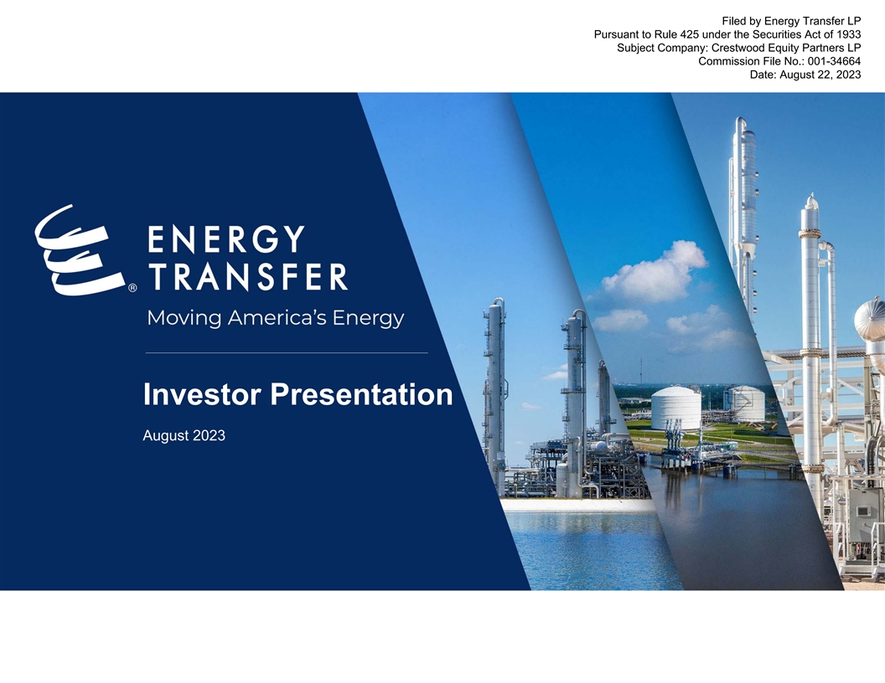
Filed by Energy Transfer LP Pursuant to Rule 425 under the Securities Act of 1933 Subject Company: Crestwood Equity Partners LP Commission File No.: 001-34664 Date: August 22, 2023 Investor Presentation August 2023

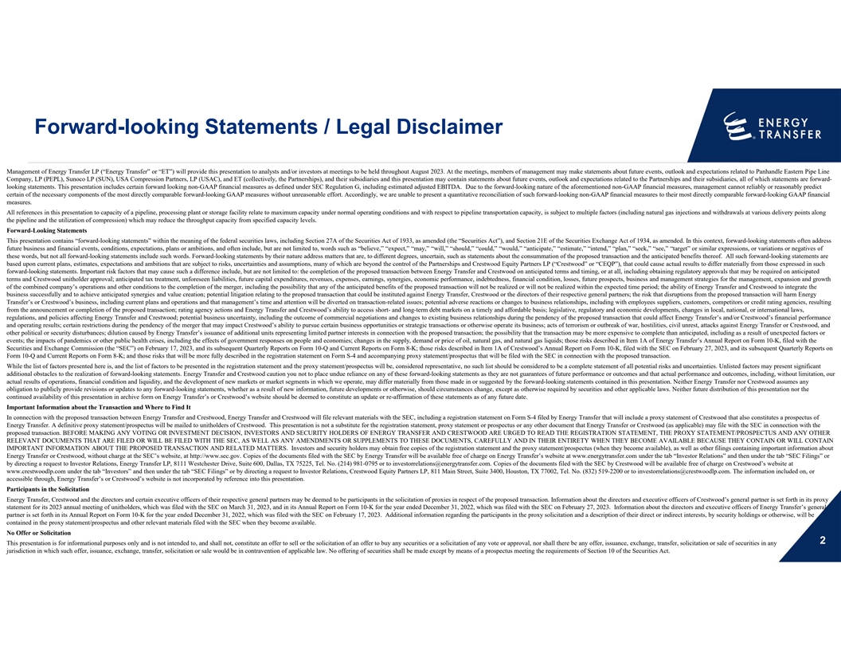
Forward-looking Statements / Legal Disclaimer Management of Energy Transfer LP (“Energy Transfer” or “ET”) will provide this presentation to analysts and/or investors at meetings to be held throughout August 2023. At the meetings, members of management may make statements about future events, outlook and expectations related to Panhandle Eastern Pipe Line Company, LP (PEPL), Sunoco LP (SUN), USA Compression Partners, LP (USAC), and ET (collectively, the Partnerships), and their subsidiaries and this presentation may contain statements about future events, outlook and expectations related to the Partnerships and their subsidiaries, all of which statements are forward- looking statements. This presentation includes certain forward looking non-GAAP financial measures as defined under SEC Regulation G, including estimated adjusted EBITDA. Due to the forward-looking nature of the aforementioned non-GAAP financial measures, management cannot reliably or reasonably predict certain of the necessary components of the most directly comparable forward-looking GAAP measures without unreasonable effort. Accordingly, we are unable to present a quantitative reconciliation of such forward-looking non-GAAP financial measures to their most directly comparable forward-looking GAAP financial measures. All references in this presentation to capacity of a pipeline, processing plant or storage facility relate to maximum capacity under normal operating conditions and with respect to pipeline transportation capacity, is subject to multiple factors (including natural gas injections and withdrawals at various delivery points along the pipeline and the utilization of compression) which may reduce the throughput capacity from specified capacity levels. Forward-Looking Statements This presentation contains “forward-looking statements” within the meaning of the federal securities laws, including Section 27A of the Securities Act of 1933, as amended (the “Securities Act”), and Section 21E of the Securities Exchange Act of 1934, as amended. In this context, forward-looking statements often address future business and financial events, conditions, expectations, plans or ambitions, and often include, but are not limited to, words such as “believe,” “expect,” “may,” “will,” “should,” “could,” “would,” “anticipate,” “estimate,” “intend,” “plan,” “seek,” “see,” “target” or similar expressions, or variations or negatives of these words, but not all forward-looking statements include such words. Forward-looking statements by their nature address matters that are, to different degrees, uncertain, such as statements about the consummation of the proposed transaction and the anticipated benefits thereof. All such forward-looking statements are based upon current plans, estimates, expectations and ambitions that are subject to risks, uncertainties and assumptions, many of which are beyond the control of the Partnerships and Crestwood Equity Partners LP (“Crestwood” or “CEQP”), that could cause actual results to differ materially from those expressed in such forward-looking statements. Important risk factors that may cause such a difference include, but are not limited to: the completion of the proposed transaction between Energy Transfer and Crestwood on anticipated terms and timing, or at all, including obtaining regulatory approvals that may be required on anticipated terms and Crestwood unitholder approval; anticipated tax treatment, unforeseen liabilities, future capital expenditures, revenues, expenses, earnings, synergies, economic performance, indebtedness, financial condition, losses, future prospects, business and management strategies for the management, expansion and growth of the combined company’s operations and other conditions to the completion of the merger, including the possibility that any of the anticipated benefits of the proposed transaction will not be realized or will not be realized within the expected time period; the ability of Energy Transfer and Crestwood to integrate the business successfully and to achieve anticipated synergies and value creation; potential litigation relating to the proposed transaction that could be instituted against Energy Transfer, Crestwood or the directors of their respective general partners; the risk that disruptions from the proposed transaction will harm Energy Transfer’s or Crestwood’s business, including current plans and operations and that management’s time and attention will be diverted on transaction-related issues; potential adverse reactions or changes to business relationships, including with employees suppliers, customers, competitors or credit rating agencies, resulting from the announcement or completion of the proposed transaction; rating agency actions and Energy Transfer and Crestwood’s ability to access short- and long-term debt markets on a timely and affordable basis; legislative, regulatory and economic developments, changes in local, national, or international laws, regulations, and policies affecting Energy Transfer and Crestwood; potential business uncertainty, including the outcome of commercial negotiations and changes to existing business relationships during the pendency of the proposed transaction that could affect Energy Transfer’s and/or Crestwood’s financial performance and operating results; certain restrictions during the pendency of the merger that may impact Crestwood’s ability to pursue certain business opportunities or strategic transactions or otherwise operate its business; acts of terrorism or outbreak of war, hostilities, civil unrest, attacks against Energy Transfer or Crestwood, and other political or security disturbances; dilution caused by Energy Transfer’s issuance of additional units representing limited partner interests in connection with the proposed transaction; the possibility that the transaction may be more expensive to complete than anticipated, including as a result of unexpected factors or events; the impacts of pandemics or other public health crises, including the effects of government responses on people and economies; changes in the supply, demand or price of oil, natural gas, and natural gas liquids; those risks described in Item 1A of Energy Transfer’s Annual Report on Form 10-K, filed with the Securities and Exchange Commission (the “SEC”) on February 17, 2023, and its subsequent Quarterly Reports on Form 10-Q and Current Reports on Form 8-K; those risks described in Item 1A of Crestwood’s Annual Report on Form 10-K, filed with the SEC on February 27, 2023, and its subsequent Quarterly Reports on Form 10-Q and Current Reports on Form 8-K; and those risks that will be more fully described in the registration statement on Form S-4 and accompanying proxy statement/prospectus that will be filed with the SEC in connection with the proposed transaction. While the list of factors presented here is, and the list of factors to be presented in the registration statement and the proxy statement/prospectus will be, considered representative, no such list should be considered to be a complete statement of all potential risks and uncertainties. Unlisted factors may present significant additional obstacles to the realization of forward-looking statements. Energy Transfer and Crestwood caution you not to place undue reliance on any of these forward-looking statements as they are not guarantees of future performance or outcomes and that actual performance and outcomes, including, without limitation, our actual results of operations, financial condition and liquidity, and the development of new markets or market segments in which we operate, may differ materially from those made in or suggested by the forward-looking statements contained in this presentation. Neither Energy Transfer nor Crestwood assumes any obligation to publicly provide revisions or updates to any forward-looking statements, whether as a result of new information, future developments or otherwise, should circumstances change, except as otherwise required by securities and other applicable laws. Neither future distribution of this presentation nor the continued availability of this presentation in archive form on Energy Transfer’s or Crestwood’s website should be deemed to constitute an update or re-affirmation of these statements as of any future date. Important Information about the Transaction and Where to Find It In connection with the proposed transaction between Energy Transfer and Crestwood, Energy Transfer and Crestwood will file relevant materials with the SEC, including a registration statement on Form S-4 filed by Energy Transfer that will include a proxy statement of Crestwood that also constitutes a prospectus of Energy Transfer. A definitive proxy statement/prospectus will be mailed to unitholders of Crestwood. This presentation is not a substitute for the registration statement, proxy statement or prospectus or any other document that Energy Transfer or Crestwood (as applicable) may file with the SEC in connection with the proposed transaction. BEFORE MAKING ANY VOTING OR INVESTMENT DECISION, INVESTORS AND SECURITY HOLDERS OF ENERGY TRANSFER AND CRESTWOOD ARE URGED TO READ THE REGISTRATION STATEMENT, THE PROXY STATEMENT/PROSPECTUS AND ANY OTHER RELEVANT DOCUMENTS THAT ARE FILED OR WILL BE FILED WITH THE SEC, AS WELL AS ANY AMENDMENTS OR SUPPLEMENTS TO THESE DOCUMENTS, CAREFULLY AND IN THEIR ENTIRETY WHEN THEY BECOME AVAILABLE BECAUSE THEY CONTAIN OR WILL CONTAIN IMPORTANT INFORMATION ABOUT THE PROPOSED TRANSACTION AND RELATED MATTERS. Investors and security holders may obtain free copies of the registration statement and the proxy statement/prospectus (when they become available), as well as other filings containing important information about Energy Transfer or Crestwood, without charge at the SEC’s website, at http://www.sec.gov. Copies of the documents filed with the SEC by Energy Transfer will be available free of charge on Energy Transfer’s website at www.energytransfer.com under the tab “Investor Relations” and then under the tab “SEC Filings” or by directing a request to Investor Relations, Energy Transfer LP, 8111 Westchester Drive, Suite 600, Dallas, TX 75225, Tel. No. (214) 981-0795 or to investorrelations@energytransfer.com. Copies of the documents filed with the SEC by Crestwood will be available free of charge on Crestwood’s website at www.crestwoodlp.com under the tab “Investors” and then under the tab “SEC Filings” or by directing a request to Investor Relations, Crestwood Equity Partners LP, 811 Main Street, Suite 3400, Houston, TX 77002, Tel. No. (832) 519-2200 or to investorrelations@crestwoodlp.com. The information included on, or accessible through, Energy Transfer’s or Crestwood’s website is not incorporated by reference into this presentation. Participants in the Solicitation Energy Transfer, Crestwood and the directors and certain executive officers of their respective general partners may be deemed to be participants in the solicitation of proxies in respect of the proposed transaction. Information about the directors and executive officers of Crestwood’s general partner is set forth in its proxy statement for its 2023 annual meeting of unitholders, which was filed with the SEC on March 31, 2023, and in its Annual Report on Form 10-K for the year ended December 31, 2022, which was filed with the SEC on February 27, 2023. Information about the directors and executive officers of Energy Transfer’s general partner is set forth in its Annual Report on Form 10-K for the year ended December 31, 2022, which was filed with the SEC on February 17, 2023. Additional information regarding the participants in the proxy solicitation and a description of their direct or indirect interests, by security holdings or otherwise, will be contained in the proxy statement/prospectus and other relevant materials filed with the SEC when they become available. No Offer or Solicitation 2 This presentation is for informational purposes only and is not intended to, and shall not, constitute an offer to sell or the solicitation of an offer to buy any securities or a solicitation of any vote or approval, nor shall there be any offer, issuance, exchange, transfer, solicitation or sale of securities in any jurisdiction in which such offer, issuance, exchange, transfer, solicitation or sale would be in contravention of applicable law. No offering of securities shall be made except by means of a prospectus meeting the requirements of Section 10 of the Securities Act.

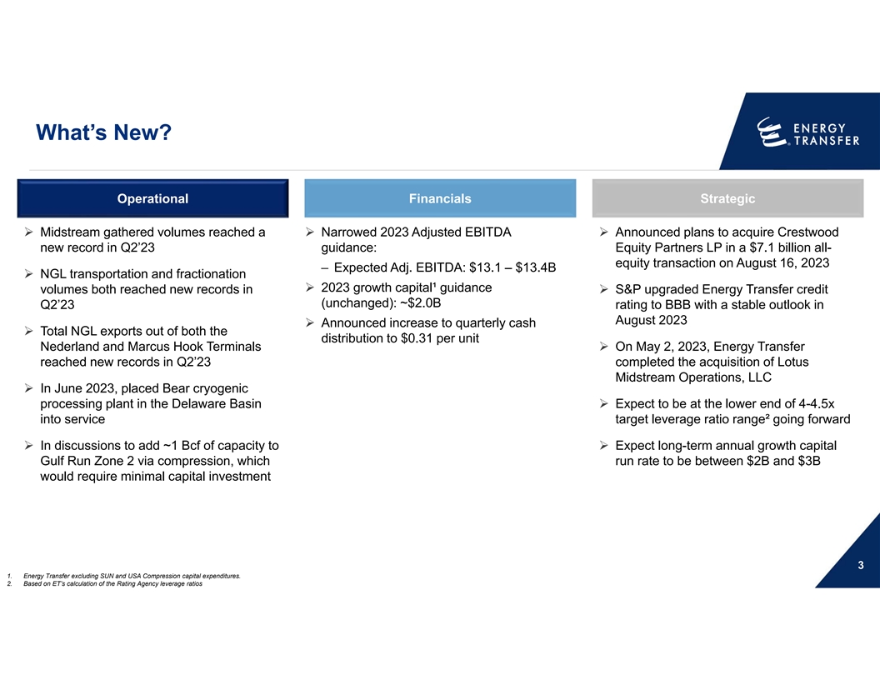
What’s New? Operational Financials Strategic Ø Midstream gathered volumes reached a Ø Narrowed 2023 Adjusted EBITDA Ø Announced plans to acquire Crestwood new record in Q2’23 guidance: Equity Partners LP in a $7.1 billion all- equity transaction on August 16, 2023 ‒ Expected Adj. EBITDA: $13.1 – $13.4B Ø NGL transportation and fractionation Ø 2023 growth capital¹ guidance volumes both reached new records in Ø S&P upgraded Energy Transfer credit (unchanged): ~$2.0B Q2’23 rating to BBB with a stable outlook in August 2023 Ø Announced increase to quarterly cash Ø Total NGL exports out of both the distribution to $0.31 per unit Nederland and Marcus Hook Terminals Ø On May 2, 2023, Energy Transfer reached new records in Q2’23 completed the acquisition of Lotus Midstream Operations, LLC Ø In June 2023, placed Bear cryogenic processing plant in the Delaware Basin Ø Expect to be at the lower end of 4-4.5x into service target leverage ratio range² going forward Ø In discussions to add ~1 Bcf of capacity to Ø Expect long-term annual growth capital Gulf Run Zone 2 via compression, which run rate to be between $2B and $3B would require minimal capital investment 3 1. Energy Transfer excluding SUN and USA Compression capital expenditures. 2. Based on ET’s calculation of the Rating Agency leverage ratios

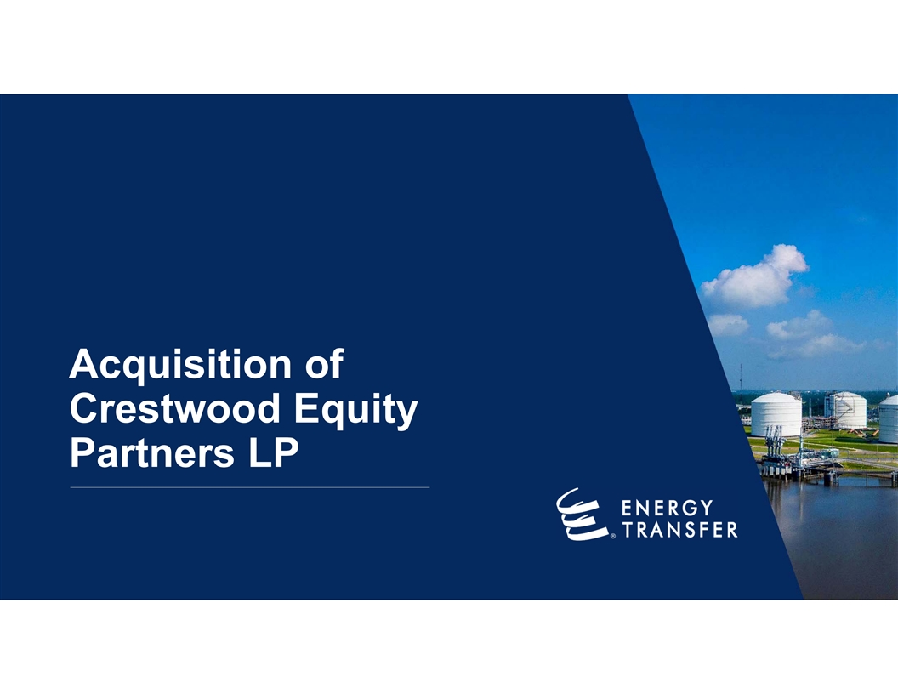
Acquisition of Crestwood Equity Partners LP

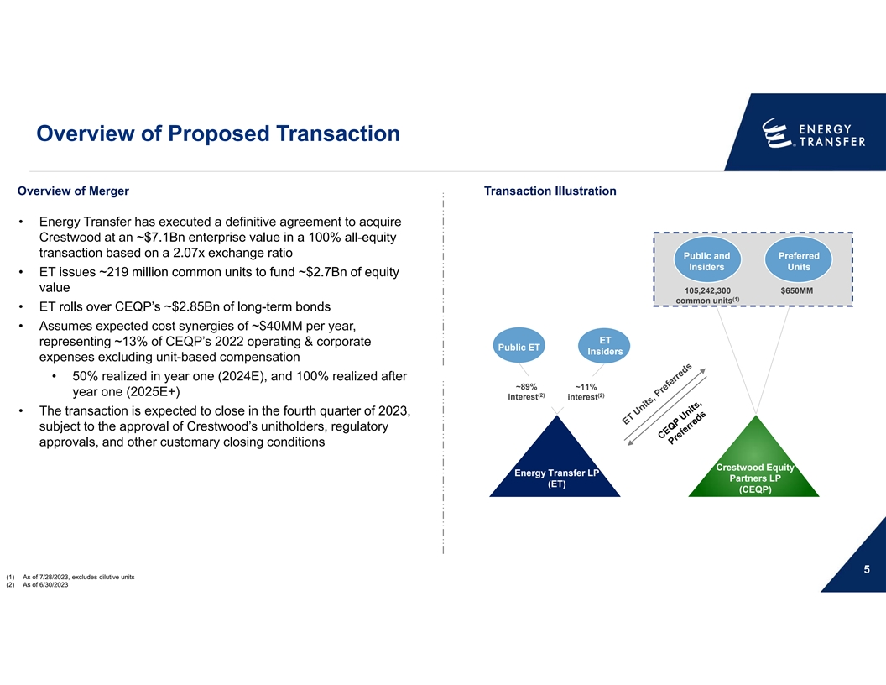
Overview of Proposed Transaction Overview of Merger Transaction Illustration • Energy Transfer has executed a definitive agreement to acquire Crestwood at an ~$7.1Bn enterprise value in a 100% all-equity transaction based on a 2.07x exchange ratio Public and Preferred Insiders Units •ET issues ~219 million common units to fund ~$2.7Bn of equity value 105,242,300 $650MM (1) common units •ET rolls over CEQP’s ~$2.85Bn of long-term bonds • Assumes expected cost synergies of ~$40MM per year, ET representing ~13% of CEQP’s 2022 operating & corporate Public ET Insiders expenses excluding unit-based compensation • 50% realized in year one (2024E), and 100% realized after ~89% ~11% year one (2025E+) (2) (2) interest interest • The transaction is expected to close in the fourth quarter of 2023, subject to the approval of Crestwood’s unitholders, regulatory approvals, and other customary closing conditions Crestwood Equity Energy Transfer LP Partners LP (ET) (CEQP) 5 (1) As of 7/28/2023, excludes dilutive units (2) As of 6/30/2023

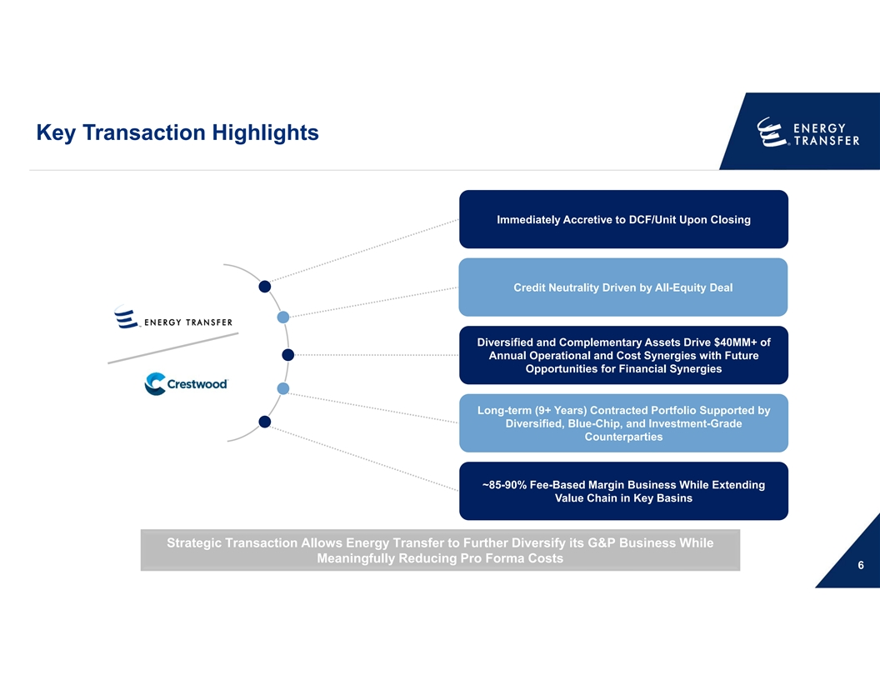
Key Transaction Highlights Immediately Accretive to DCF/Unit Upon Closing Credit Neutrality Driven by All-Equity Deal Diversified and Complementary Assets Drive $40MM+ of Annual Operational and Cost Synergies with Future Opportunities for Financial Synergies Long-term (9+ Years) Contracted Portfolio Supported by Diversified, Blue-Chip, and Investment-Grade Counterparties ~85-90% Fee-Based Margin Business While Extending Value Chain in Key Basins Strategic Transaction Allows Energy Transfer to Further Diversify its G&P Business While Meaningfully Reducing Pro Forma Costs 6

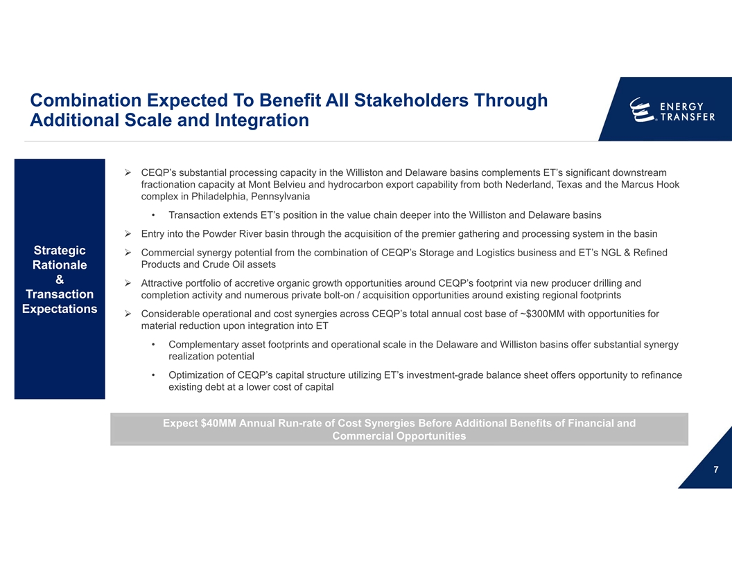
Combination Expected To Benefit All Stakeholders Through Additional Scale and Integration Ø CEQP’s substantial processing capacity in the Williston and Delaware basins complements ET’s significant downstream fractionation capacity at Mont Belvieu and hydrocarbon export capability from both Nederland, Texas and the Marcus Hook complex in Philadelphia, Pennsylvania • Transaction extends ET’s position in the value chain deeper into the Williston and Delaware basins Ø Entry into the Powder River basin through the acquisition of the premier gathering and processing system in the basin Strategic Ø Commercial synergy potential from the combination of CEQP’s Storage and Logistics business and ET’s NGL & Refined Products and Crude Oil assets Rationale & Ø Attractive portfolio of accretive organic growth opportunities around CEQP’s footprint via new producer drilling and Transaction completion activity and numerous private bolt-on / acquisition opportunities around existing regional footprints Expectations Ø Considerable operational and cost synergies across CEQP’s total annual cost base of ~$300MM with opportunities for material reduction upon integration into ET • Complementary asset footprints and operational scale in the Delaware and Williston basins offer substantial synergy realization potential • Optimization of CEQP’s capital structure utilizing ET’s investment-grade balance sheet offers opportunity to refinance existing debt at a lower cost of capital Expect $40MM Annual Run-rate of Cost Synergies Before Additional Benefits of Financial and Commercial Opportunities 7

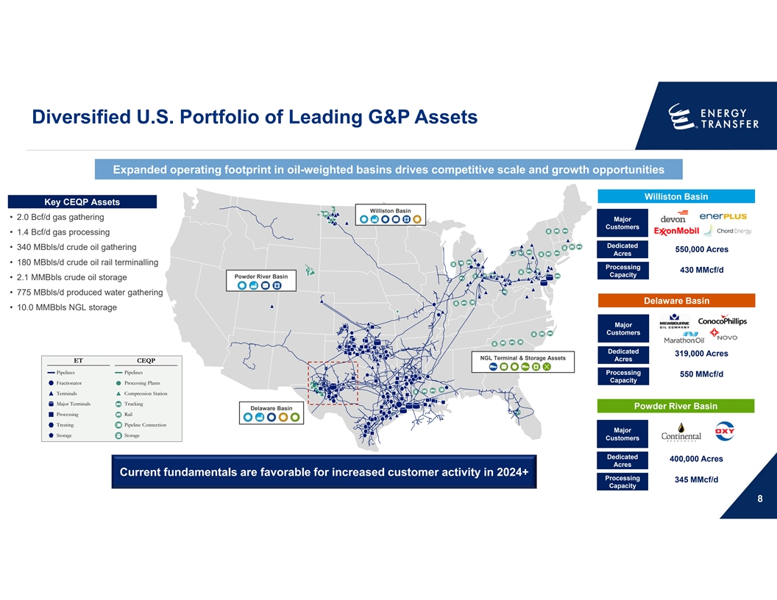
Diversified U.S. Portfolio of Leading G&P Assets Expanded operating footprint in oil-weighted basins drives competitive scale and growth opportunities Williston Basin Key CEQP Assets Williston Basin • 2.0 Bcf/d gas gathering Major Customers • 1.4 Bcf/d gas processing Dedicated • 340 MBbls/d crude oil gathering 550,000 Acres Acres • 180 MBbls/d crude oil rail terminalling Processing 430 MMcf/d Capacity Powder River Basin • 2.1 MMBbls crude oil storage • 775 MBbls/d produced water gathering Delaware Basin • 10.0 MMBbls NGL storage Major Customers Dedicated 319,000 Acres NGL Terminal & Storage Assets Acres ET CEQP Pipelines Pipelines Processing 550 MMcf/d Capacity Fractionator Processing Plants Terminals Compression Station Major Terminals Trucking Powder River Basin Delaware Basin Processing Rail Treating Pipeline Connection Major Storage Storage Customers Dedicated 400,000 Acres Acres Current fundamentals are favorable for increased customer activity in 2024+ Processing 345 MMcf/d Capacity 8

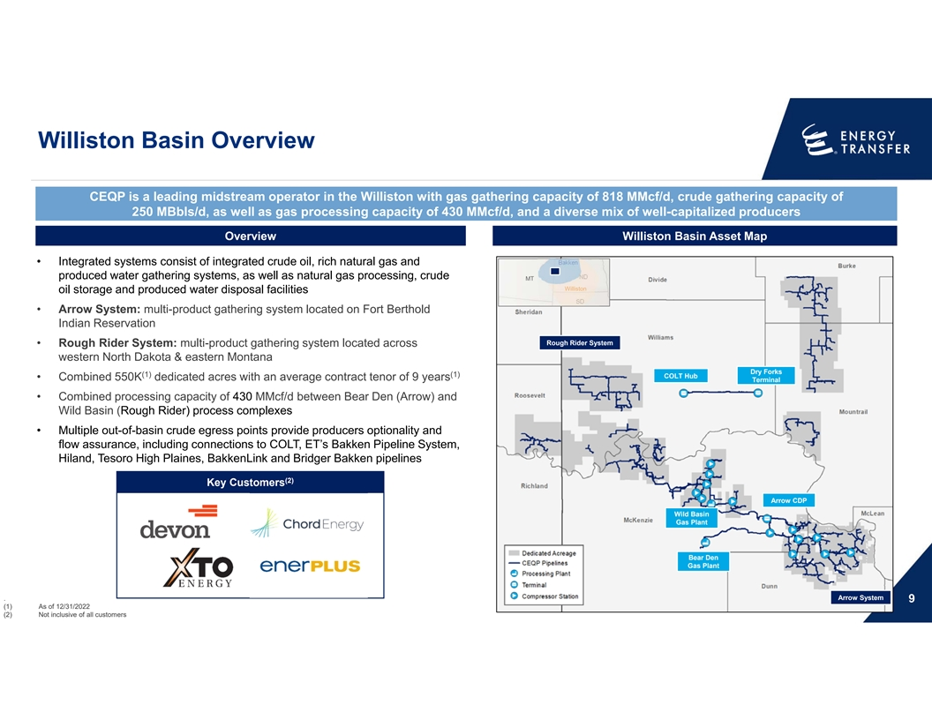
Williston Basin Overview CEQP is a leading midstream operator in the Williston with gas gathering capacity of 818 MMcf/d, crude gathering capacity of 250 MBbls/d, as well as gas processing capacity of 430 MMcf/d, and a diverse mix of well-capitalized producers Overview Williston Basin Asset Map Bakken • Integrated systems consist of integrated crude oil, rich natural gas and produced water gathering systems, as well as natural gas processing, crude ND MT Williston oil storage and produced water disposal facilities SD • Arrow System: multi-product gathering system located on Fort Berthold Indian Reservation Rough Rider System • Rough Rider System: multi-product gathering system located across western North Dakota & eastern Montana Dry Forks (1) (1) COLT Hub • Combined 550K dedicated acres with an average contract tenor of 9 years Terminal • Combined processing capacity of 430 MMcf/d between Bear Den (Arrow) and Wild Basin (Rough Rider) process complexes • Multiple out-of-basin crude egress points provide producers optionality and flow assurance, including connections to COLT, ET’s Bakken Pipeline System, Hiland, Tesoro High Plaines, BakkenLink and Bridger Bakken pipelines (2) Key Customers Arrow CDP Wild Basin Gas Plant Bear Den Gas Plant Arrow System . 9 (1) As of 12/31/2022 (2) Not inclusive of all customers

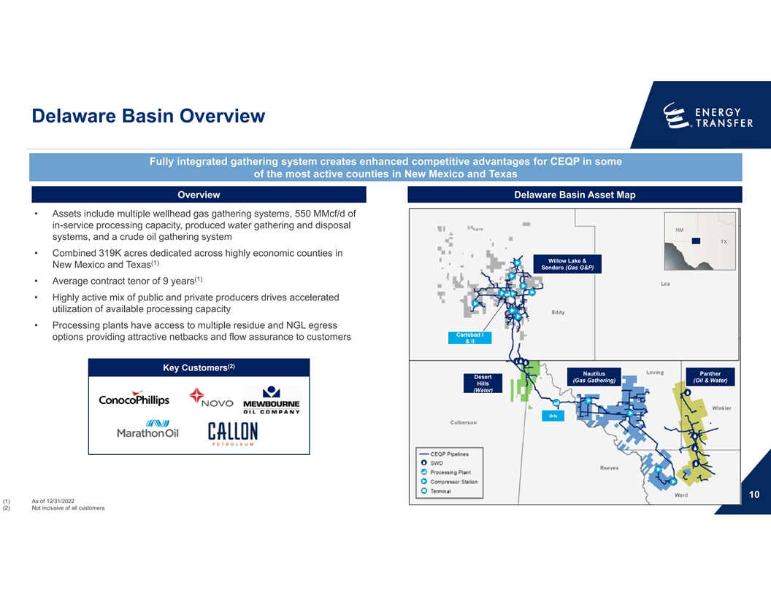
Delaware Basin Overview Fully integrated gathering system creates enhanced competitive advantages for CEQP in some of the most active counties in New Mexico and Texas Overview Delaware Basin Asset Map • Assets include multiple wellhead gas gathering systems, 550 MMcf/d of in-service processing capacity, produced water gathering and disposal NM NM NM systems, and a crude oil gathering system TX TX TX • Combined 319K acres dedicated across highly economic counties in Willow Lake & (1) New Mexico and Texas Sendero (Gas G&P) (1) • Average contract tenor of 9 years • Highly active mix of public and private producers drives accelerated utilization of available processing capacity • Processing plants have access to multiple residue and NGL egress Carlsbad I options providing attractive netbacks and flow assurance to customers & II (2) Key Customers Nautilus Panther Desert (Gas Gathering) (Oil & Water) Hills (Water) Orla 10 (1) As of 12/31/2022 (2) Not inclusive of all customers

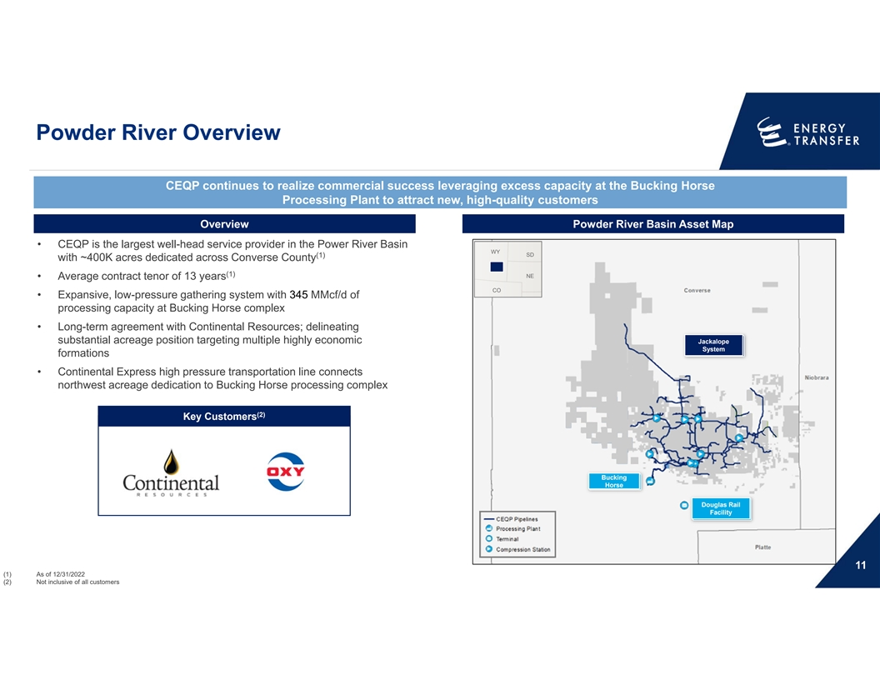
Powder River Overview CEQP continues to realize commercial success leveraging excess capacity at the Bucking Horse Processing Plant to attract new, high-quality customers Overview Powder River Basin Asset Map • CEQP is the largest well-head service provider in the Power River Basin WY WY WY SD SD SD (1) with ~400K acres dedicated across Converse County (1) NE NE NE • Average contract tenor of 13 years CO CO CO • Expansive, low-pressure gathering system with 345 MMcf/d of processing capacity at Bucking Horse complex • Long-term agreement with Continental Resources; delineating substantial acreage position targeting multiple highly economic Jackalope System formations • Continental Express high pressure transportation line connects northwest acreage dedication to Bucking Horse processing complex (2) Key Customers Bucking Horse Douglas Rail Facility 11 (1) As of 12/31/2022 (2) Not inclusive of all customers

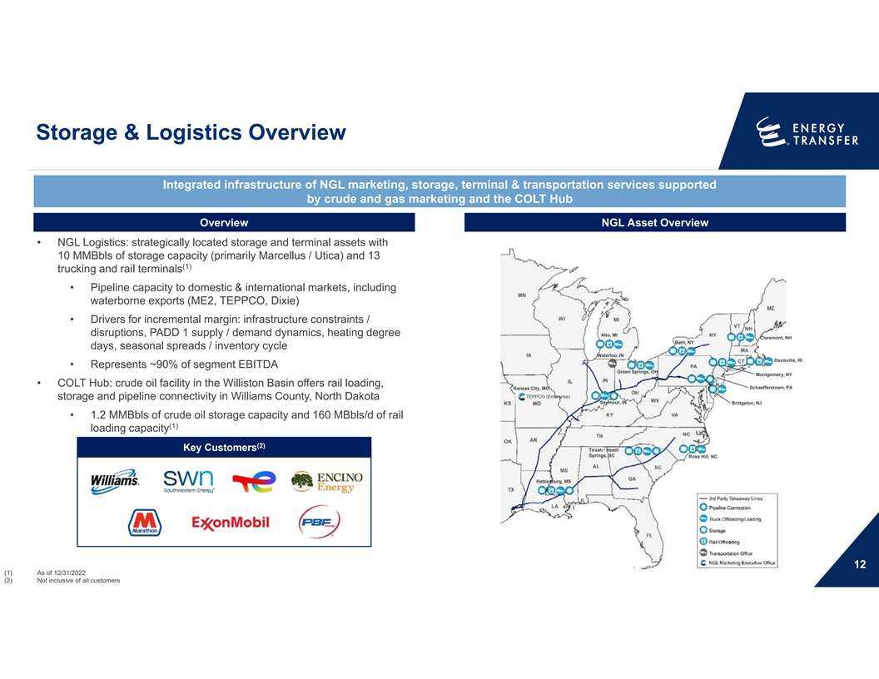
Storage & Logistics Overview Integrated infrastructure of NGL marketing, storage, terminal & transportation services supported by crude and gas marketing and the COLT Hub Overview NGL Asset Overview • NGL Logistics: strategically located storage and terminal assets with 10 MMBbls of storage capacity (primarily Marcellus / Utica) and 13 (1) trucking and rail terminals • Pipeline capacity to domestic & international markets, including waterborne exports (ME2, TEPPCO, Dixie) • Drivers for incremental margin: infrastructure constraints / disruptions, PADD 1 supply / demand dynamics, heating degree Alto, MI Claremont, NH Bath, NY days, seasonal spreads / inventory cycle Waterloo, IN Davisville, RI • Represents ~90% of segment EBITDA Green Springs, OH Montgomery, NY • COLT Hub: crude oil facility in the Williston Basin offers rail loading, Schaefferstown, PA Kansas City, MO TEPPCO (Enterprise) storage and pipeline connectivity in Williams County, North Dakota Seymour, IN Bridgeton, NJ • 1.2 MMBbls of crude oil storage capacity and 160 MBbls/d of rail (1) loading capacity (2) Key Customers Tirzah / Heath Springs, SC Rose Hill, NC Hattiesburg, MS 12 (1) As of 12/31/2022 (2) Not inclusive of all customers

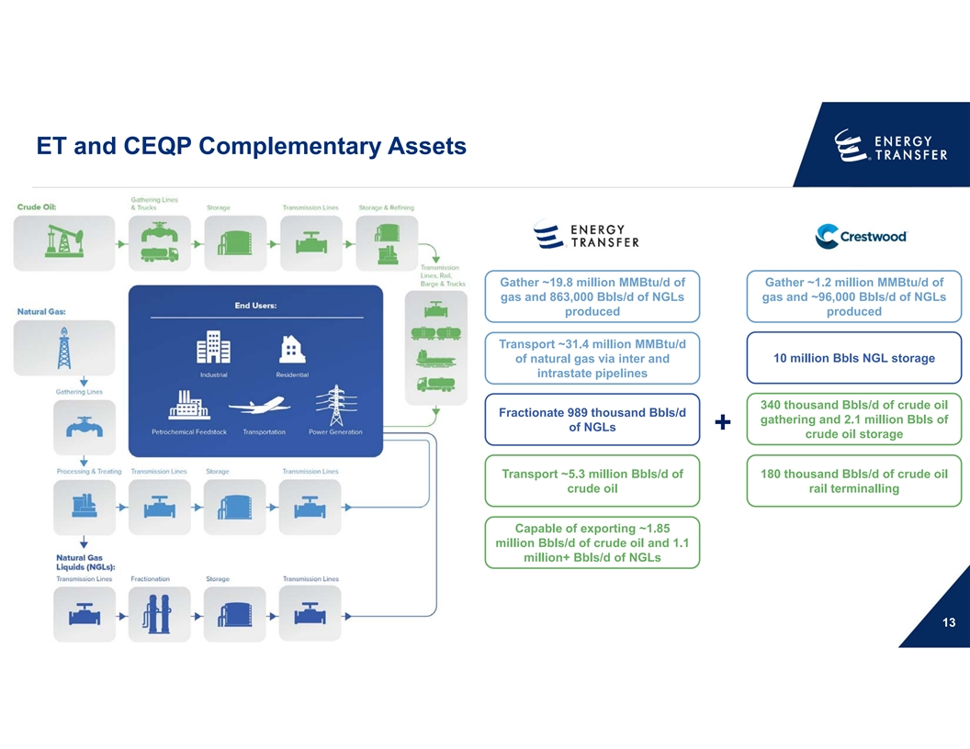
ET and CEQP Complementary Assets Gather ~19.8 million MMBtu/d of Gather ~1.2 million MMBtu/d of gas and 863,000 Bbls/d of NGLs gas and ~96,000 Bbls/d of NGLs produced produced Transport ~31.4 million MMBtu/d 10 million Bbls NGL storage of natural gas via inter and intrastate pipelines 340 thousand Bbls/d of crude oil Fractionate 989 thousand Bbls/d gathering and 2.1 million Bbls of of NGLs + crude oil storage Transport ~5.3 million Bbls/d of 180 thousand Bbls/d of crude oil crude oil rail terminalling Capable of exporting ~1.85 million Bbls/d of crude oil and 1.1 million+ Bbls/d of NGLs 13

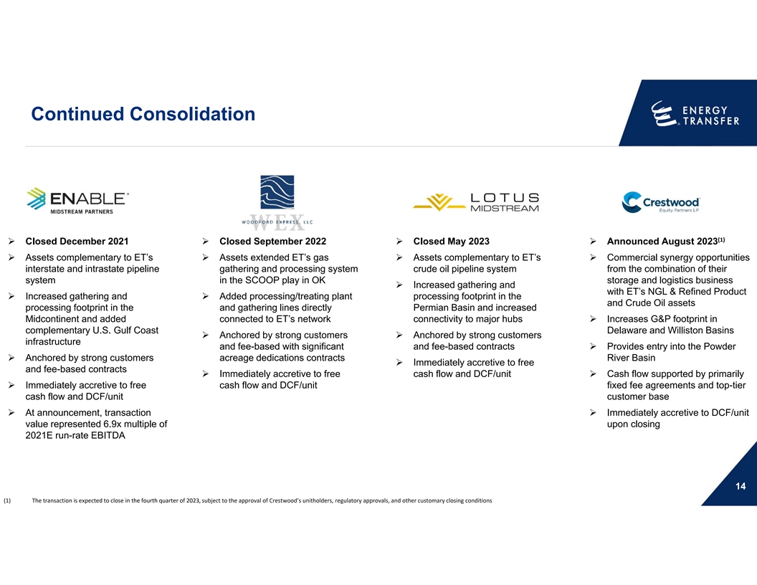
Continued Consolidation (1) Ø Closed December 2021Ø Closed September 2022Ø Closed May 2023Ø Announced August 2023 Ø Assets complementary to ET’s Ø Assets extended ET’s gas Ø Assets complementary to ET’s Ø Commercial synergy opportunities interstate and intrastate pipeline gathering and processing system crude oil pipeline system from the combination of their system in the SCOOP play in OK storage and logistics business Ø Increased gathering and with ET’s NGL & Refined Product Ø Increased gathering and Ø Added processing/treating plant processing footprint in the and Crude Oil assets processing footprint in the and gathering lines directly Permian Basin and increased Midcontinent and added connected to ET’s network connectivity to major hubsØ Increases G&P footprint in complementary U.S. Gulf Coast Delaware and Williston Basins Ø Anchored by strong customers Ø Anchored by strong customers infrastructure and fee-based with significant and fee-based contractsØ Provides entry into the Powder Ø Anchored by strong customers acreage dedications contracts River Basin Ø Immediately accretive to free and fee-based contracts Ø Immediately accretive to free cash flow and DCF/unitØ Cash flow supported by primarily Ø Immediately accretive to free cash flow and DCF/unit fixed fee agreements and top-tier cash flow and DCF/unit customer base Ø At announcement, transaction Ø Immediately accretive to DCF/unit value represented 6.9x multiple of upon closing 2021E run-rate EBITDA 14 (1) The transaction is expected to close in the fourth quarter of 2023, subject to the approval of Crestwood’s unitholders, regulatory approvals, and other customary closing conditions

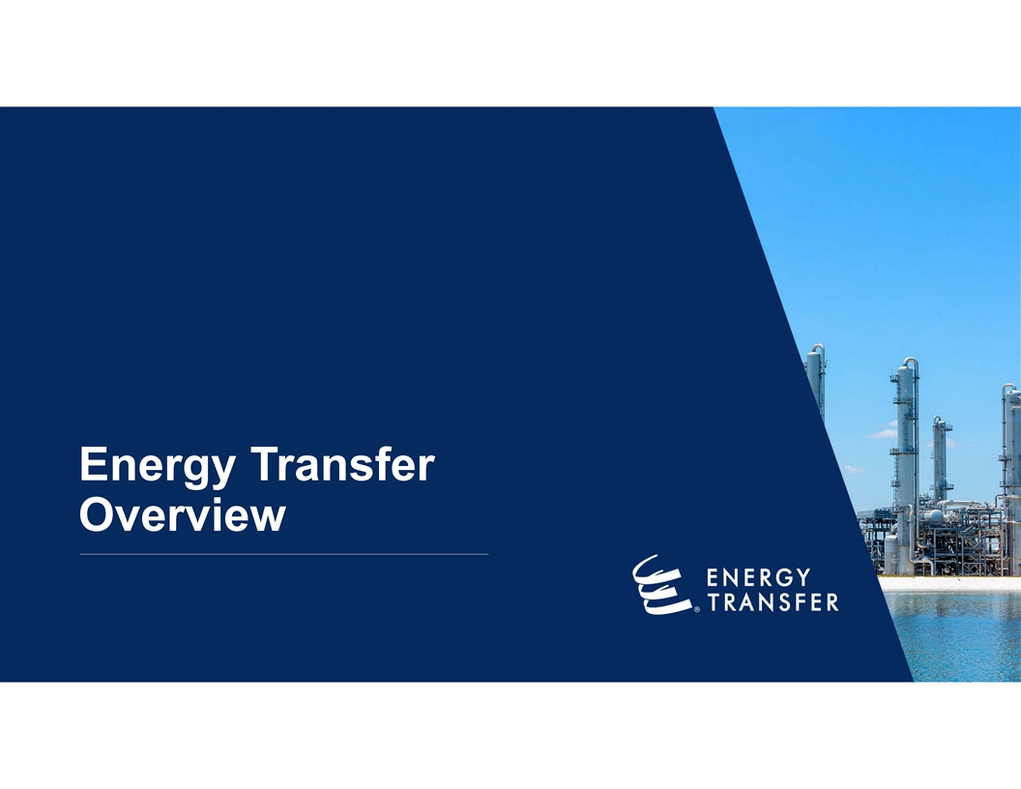
Energy Transfer Overview

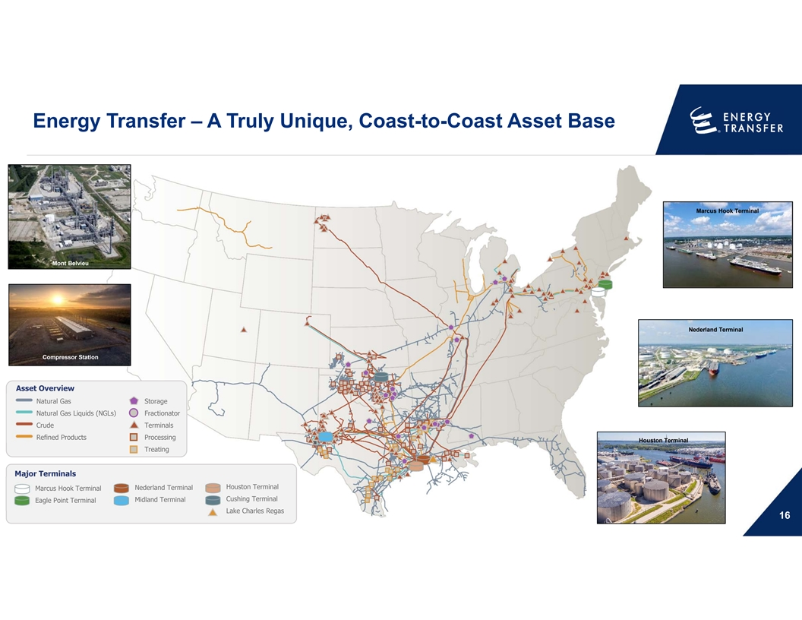
Energy Transfer – A Truly Unique, Coast-to-Coast Asset Base Marcus Hook Terminal Mont Belvieu Nederland Terminal Compressor Station Asset Overview Natural Gas Storage Natural Gas Liquids (NGLs) Fractionator Crude Terminals Refined Products Processing Houston Terminal Treating Major Terminals Houston Terminal Nederland Terminal Marcus Hook Terminal Cushing Terminal Midland Terminal Eagle Point Terminal Lake Charles Regas 16

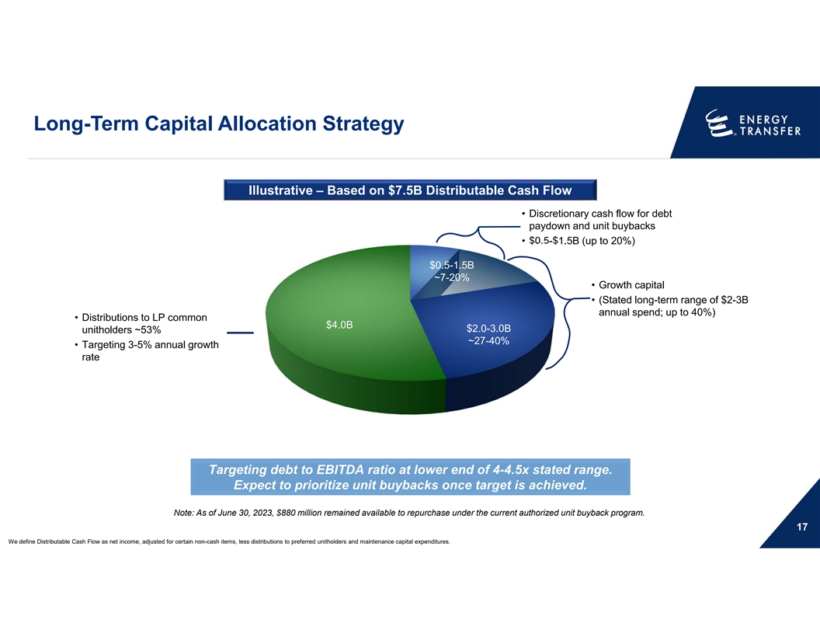
Long-Term Capital Allocation Strategy Illustrative – Based on $7.5B Distributable Cash Flow • Discretionary cash flow for debt paydown and unit buybacks • $0.5-$1.5B (up to 20%) $0.5-1.5B ~7-20% • Growth capital • (Stated long-term range of $2-3B annual spend; up to 40%) • Distributions to LP common $4.0B $2.0-3.0B unitholders ~53% ~27-40% • Targeting 3-5% annual growth rate Targeting debt to EBITDA ratio at lower end of 4-4.5x stated range. Expect to prioritize unit buybacks once target is achieved. Note: As of June 30, 2023, $880 million remained available to repurchase under the current authorized unit buyback program. 17 We define Distributable Cash Flow as net income, adjusted for certain non-cash items, less distributions to preferred unitholders and maintenance capital expenditures.

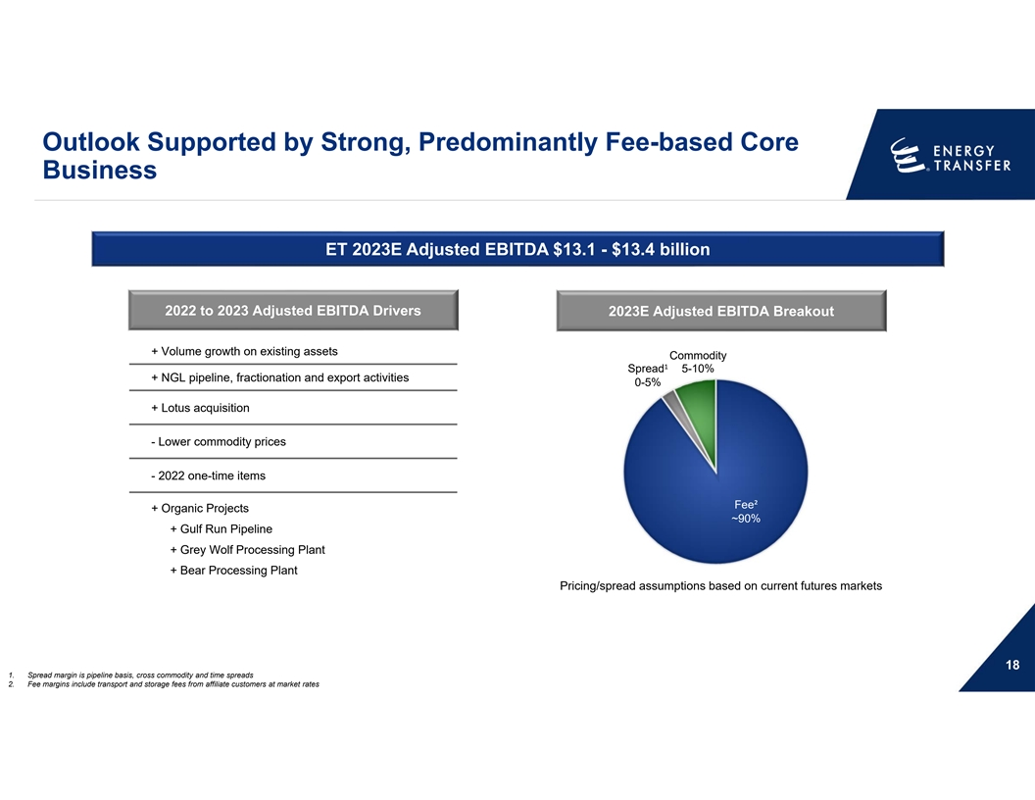
Outlook Supported by Strong, Predominantly Fee-based Core Business ET 2023E Adjusted EBITDA $13.1 - $13.4 billion 2022 to 2023 Adjusted EBITDA Drivers 2023E Adjusted EBITDA Breakout + Volume growth on existing assets Commodity 1 Spread 5-10% + NGL pipeline, fractionation and export activities 0-5% + Lotus acquisition - Lower commodity prices - 2022 one-time items Fee² + Organic Projects ~90% + Gulf Run Pipeline + Grey Wolf Processing Plant + Bear Processing Plant Pricing/spread assumptions based on current futures markets 18 1. Spread margin is pipeline basis, cross commodity and time spreads 2. Fee margins include transport and storage fees from affiliate customers at market rates

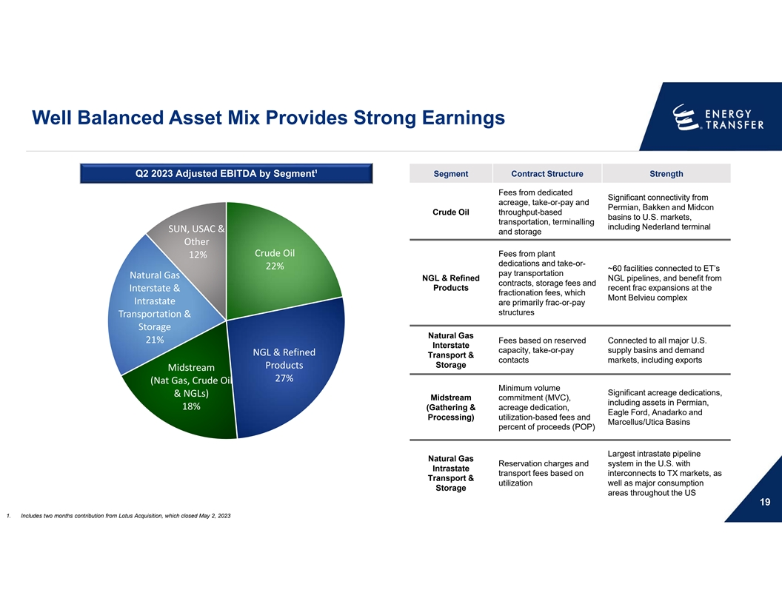
Well Balanced Asset Mix Provides Strong Earnings Q2 2023 Adjusted EBITDA by Segment¹ Segment Contract Structure Strength Fees from dedicated Significant connectivity from acreage, take-or-pay and Permian, Bakken and Midcon Crude Oil throughput-based basins to U.S. markets, transportation, terminalling including Nederland terminal SUN, USAC & and storage Other Crude Oil Fees from plant 12% dedications and take-or- 22% ~60 facilities connected to ET’s pay transportation Natural Gas NGL & Refined NGL pipelines, and benefit from contracts, storage fees and Interstate & Products recent frac expansions at the fractionation fees, which Mont Belvieu complex Intrastate are primarily frac-or-pay structures Transportation & Storage Natural Gas 21% Fees based on reserved Connected to all major U.S. Interstate capacity, take-or-pay supply basins and demand NGL & Refined Transport & contacts markets, including exports Storage Products Midstream 27% (Nat Gas, Crude Oil Minimum volume Significant acreage dedications, & NGLs) Midstream commitment (MVC), including assets in Permian, 18% (Gathering & acreage dedication, Eagle Ford, Anadarko and Processing) utilization-based fees and Marcellus/Utica Basins percent of proceeds (POP) Largest intrastate pipeline Natural Gas Reservation charges and system in the U.S. with Intrastate transport fees based on interconnects to TX markets, as Transport & utilization well as major consumption Storage areas throughout the US 19 1. Includes two months contribution from Lotus Acquisition, which closed May 2, 2023

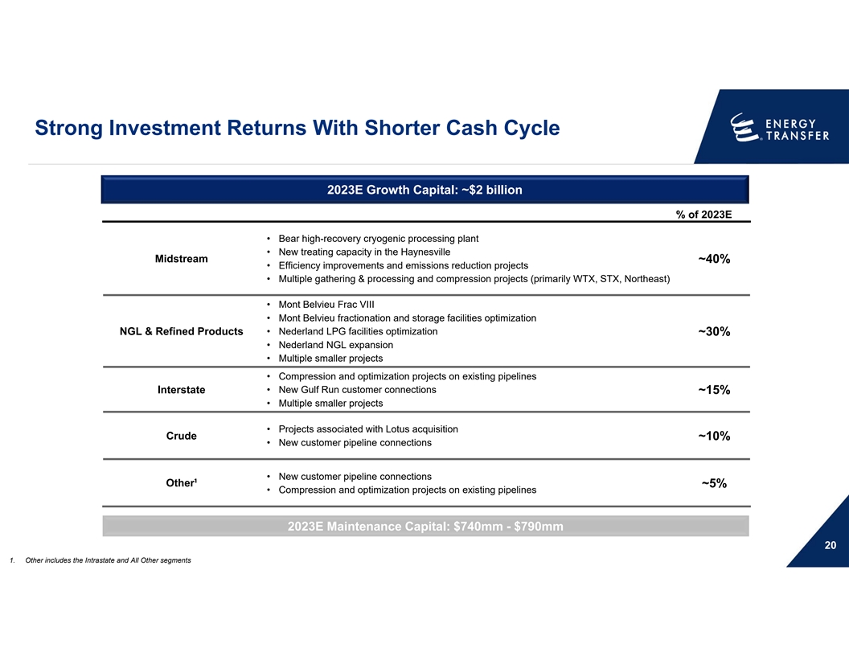
Strong Investment Returns With Shorter Cash Cycle 2023E Growth Capital: ~$2 billion % of 2023E • Bear high-recovery cryogenic processing plant • New treating capacity in the Haynesville Midstream ~40% • Efficiency improvements and emissions reduction projects • Multiple gathering & processing and compression projects (primarily WTX, STX, Northeast) • Mont Belvieu Frac VIII • Mont Belvieu fractionation and storage facilities optimization • Nederland LPG facilities optimization NGL & Refined Products ~30% • Nederland NGL expansion • Multiple smaller projects • Compression and optimization projects on existing pipelines Interstate • New Gulf Run customer connections ~15% • Multiple smaller projects • Projects associated with Lotus acquisition Crude ~10% • New customer pipeline connections • New customer pipeline connections Other¹ ~5% • Compression and optimization projects on existing pipelines 2023E Maintenance Capital: $740mm - $790mm 20 1. Other includes the Intrastate and All Other segments

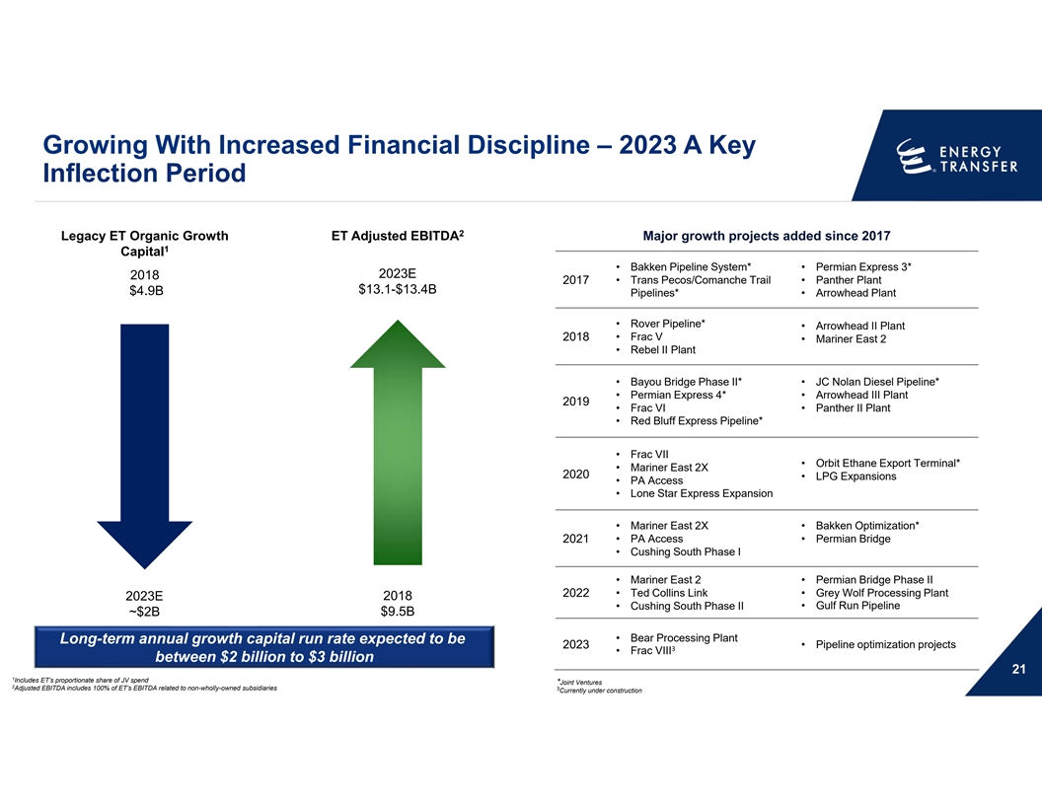
Growing With Increased Financial Discipline – 2023 A Key Inflection Period 2 Legacy ET Organic Growth ET Adjusted EBITDA Major growth projects added since 2017 1 Capital • Bakken Pipeline System* • Permian Express 3* 2023E 2018 2017 • Trans Pecos/Comanche Trail •Panther Plant $13.1-$13.4B $4.9B Pipelines* • Arrowhead Plant • Rover Pipeline* • Arrowhead II Plant 2018 • Frac V • Mariner East 2 • Rebel II Plant • Bayou Bridge Phase II* • JC Nolan Diesel Pipeline* • Permian Express 4* • Arrowhead III Plant 2019 •Frac VI • Panther II Plant • Red Bluff Express Pipeline* • Frac VII • Orbit Ethane Export Terminal* • Mariner East 2X 2020 • LPG Expansions • PA Access • Lone Star Express Expansion • Mariner East 2X • Bakken Optimization* 2021 • PA Access • Permian Bridge • Cushing South Phase I • Mariner East 2 • Permian Bridge Phase II 2022 • Ted Collins Link • Grey Wolf Processing Plant 2018 2023E • Gulf Run Pipeline • Cushing South Phase II $9.5B ~$2B • Bear Processing Plant Long-term annual growth capital run rate expected to be 2023 • Pipeline optimization projects 3 • Frac VIII between $2 billion to $3 billion 21 1 Includes ET’s proportionate share of JV spend *Joint Ventures 2 Adjusted EBITDA includes 100% of ET’s EBITDA related to non-wholly-owned subsidiaries 3 Currently under construction

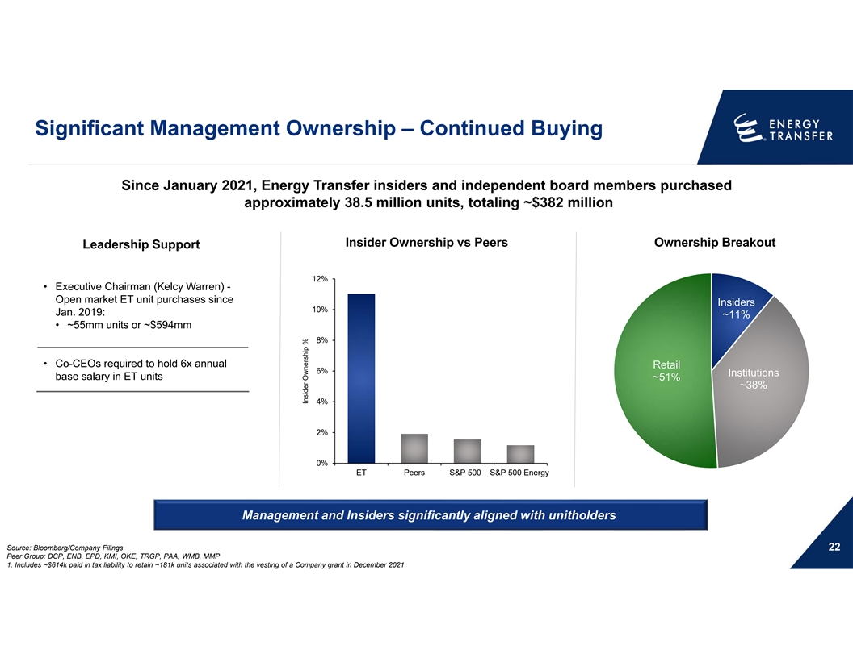
Significant Management Ownership – Continued Buying Since January 2021, Energy Transfer insiders and independent board members purchased approximately 38.5 million units, totaling ~$382 million Insider Ownership vs Peers Ownership Breakout Leadership Support 12% • Executive Chairman (Kelcy Warren) - Open market ET unit purchases since Insiders 10% Jan. 2019: ~11% • ~55mm units or ~$594mm 8% • Co-CEOs required to hold 6x annual Retail 6% Institutions base salary in ET units ~51% ~38% 4% 2% 0% ET Peers S&P 500 S&P 500 Energy Management and Insiders significantly aligned with unitholders Source: Bloomberg/Company Filings 22 Peer Group: DCP, ENB, EPD, KMI, OKE, TRGP, PAA, WMB, MMP 1. Includes ~$614k paid in tax liability to retain ~181k units associated with the vesting of a Company grant in December 2021 Insider Ownership %

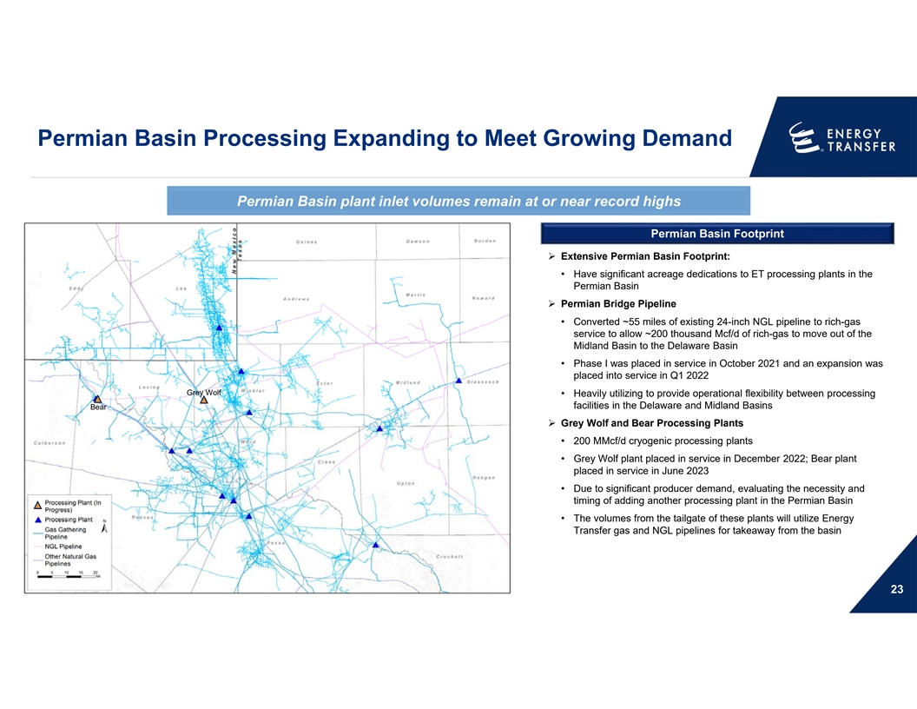
Permian Basin Processing Expanding to Meet Growing Demand Permian Basin plant inlet volumes remain at or near record highs Permian Basin Footprint Ø Extensive Permian Basin Footprint: • Have significant acreage dedications to ET processing plants in the Permian Basin Ø Permian Bridge Pipeline • Converted ~55 miles of existing 24-inch NGL pipeline to rich-gas service to allow ~200 thousand Mcf/d of rich-gas to move out of the Midland Basin to the Delaware Basin • Phase I was placed in service in October 2021 and an expansion was placed into service in Q1 2022 Grey Wolf • Heavily utilizing to provide operational flexibility between processing facilities in the Delaware and Midland Basins Bear Ø Grey Wolf and Bear Processing Plants • 200 MMcf/d cryogenic processing plants • Grey Wolf plant placed in service in December 2022; Bear plant placed in service in June 2023 • Due to significant producer demand, evaluating the necessity and timing of adding another processing plant in the Permian Basin • The volumes from the tailgate of these plants will utilize Energy Transfer gas and NGL pipelines for takeaway from the basin 23

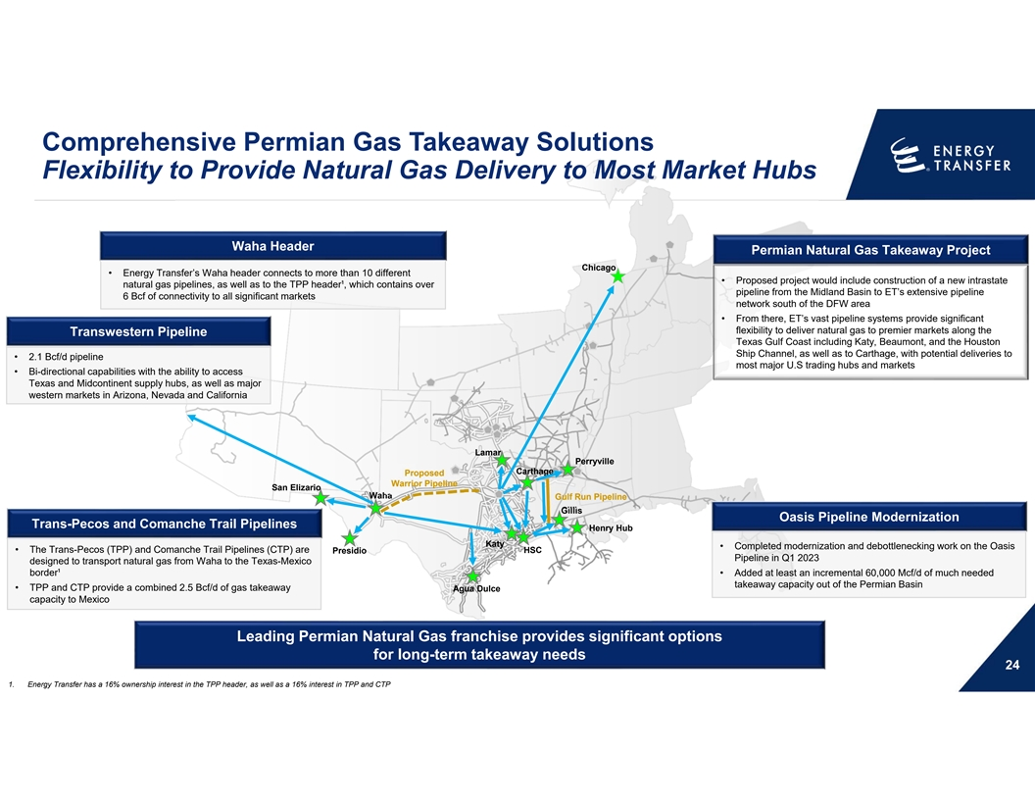
Comprehensive Permian Gas Takeaway Solutions Flexibility to Provide Natural Gas Delivery to Most Market Hubs Waha Header Permian Natural Gas Takeaway Project Chicago • Energy Transfer’s Waha header connects to more than 10 different • Proposed project would include construction of a new intrastate natural gas pipelines, as well as to the TPP header¹, which contains over pipeline from the Midland Basin to ET’s extensive pipeline 6 Bcf of connectivity to all significant markets network south of the DFW area • From there, ET’s vast pipeline systems provide significant flexibility to deliver natural gas to premier markets along the Transwestern Pipeline Texas Gulf Coast including Katy, Beaumont, and the Houston Ship Channel, as well as to Carthage, with potential deliveries to • 2.1 Bcf/d pipeline most major U.S trading hubs and markets • Bi-directional capabilities with the ability to access Texas and Midcontinent supply hubs, as well as major western markets in Arizona, Nevada and California Lamar Perryville Carthage Proposed Warrior Pipeline San Elizario Waha Gulf Run Pipeline Gillis Oasis Pipeline Modernization Trans-Pecos and Comanche Trail Pipelines Henry Hub Katy • Completed modernization and debottlenecking work on the Oasis • The Trans-Pecos (TPP) and Comanche Trail Pipelines (CTP) are HSC Presidio Pipeline in Q1 2023 designed to transport natural gas from Waha to the Texas-Mexico border¹ • Added at least an incremental 60,000 Mcf/d of much needed takeaway capacity out of the Permian Basin • TPP and CTP provide a combined 2.5 Bcf/d of gas takeaway Agua Dulce capacity to Mexico Leading Permian Natural Gas franchise provides significant options for long-term takeaway needs 24 1. Energy Transfer has a 16% ownership interest in the TPP header, as well as a 16% interest in TPP and CTP

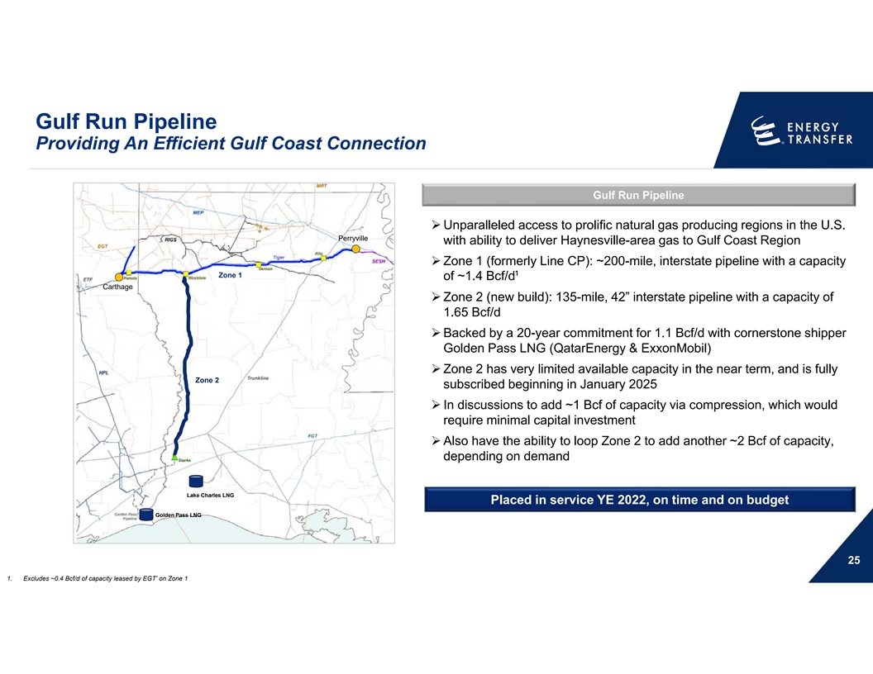
Gulf Run Pipeline Providing An Efficient Gulf Coast Connection Gulf Run Pipeline Ø Unparalleled access to prolific natural gas producing regions in the U.S. Perryville with ability to deliver Haynesville-area gas to Gulf Coast Region Ø Zone 1 (formerly Line CP): ~200-mile, interstate pipeline with a capacity Zone 1 of ~1.4 Bcf/d¹ Carthage Ø Zone 2 (new build): 135-mile, 42” interstate pipeline with a capacity of 1.65 Bcf/d Ø Backed by a 20-year commitment for 1.1 Bcf/d with cornerstone shipper Golden Pass LNG (QatarEnergy & ExxonMobil) Ø Zone 2 has very limited available capacity in the near term, and is fully Zone 2 subscribed beginning in January 2025 Ø In discussions to add ~1 Bcf of capacity via compression, which would require minimal capital investment Ø Also have the ability to loop Zone 2 to add another ~2 Bcf of capacity, depending on demand Lake Charles LNG Placed in service YE 2022, on time and on budget Golden Pass LNG 25 1. Excludes ~0.4 Bcf/d of capacity leased by EGT’ on Zone 1

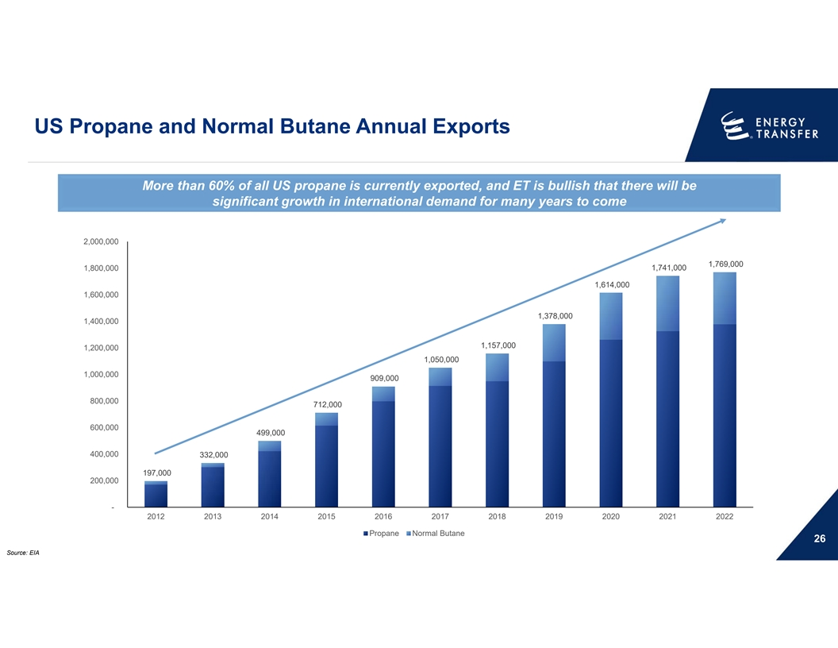
US Propane and Normal Butane Annual Exports More than 60% of all US propane is currently exported, and ET is bullish that there will be significant growth in international demand for many years to come 2,000,000 1,769,000 1,800,000 1,741,000 1,614,000 1,600,000 1,378,000 1,400,000 1,157,000 1,200,000 1,050,000 1,000,000 909,000 800,000 712,000 600,000 499,000 400,000 332,000 197,000 200,000 - 2012 2013 2014 2015 2016 2017 2018 2019 2020 2021 2022 Propane Normal Butane 26 Source: EIA

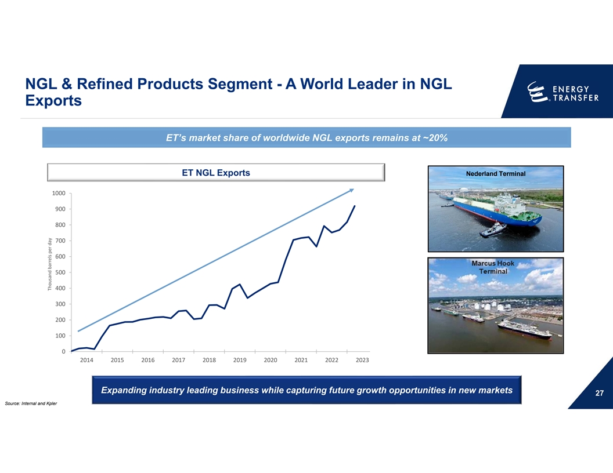
NGL & Refined Products Segment - A World Leader in NGL Exports ET’s market share of worldwide NGL exports remains at ~20% ET NGL Exports Nederland Terminal 1000 900 800 700 600 500 400 300 200 100 0 2014 2015 2016 2017 2018 2019 2020 2021 2022 2023 Expanding industry leading business while capturing future growth opportunities in new markets 27 Source: Internal and Kpler Thousand barrels per day

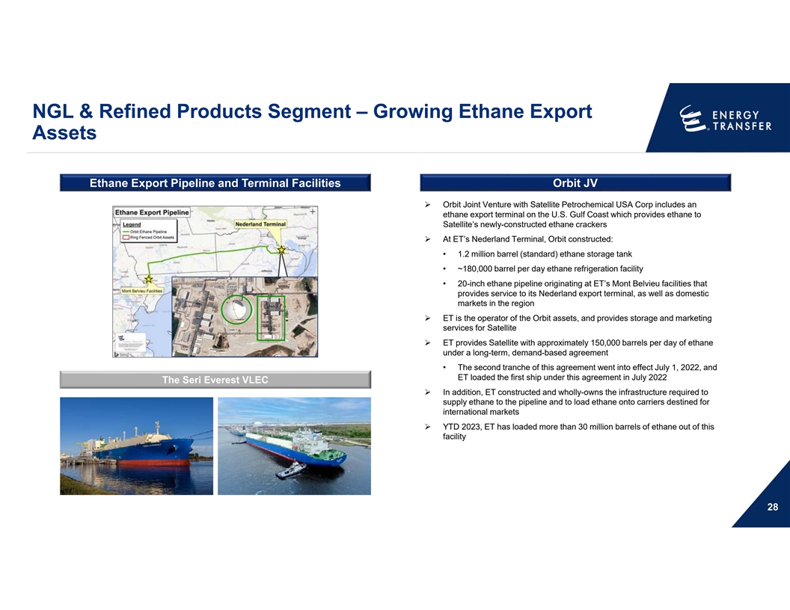
NGL & Refined Products Segment – Growing Ethane Export Assets Ethane Export Pipeline and Terminal Facilities Orbit JV Ø Orbit Joint Venture with Satellite Petrochemical USA Corp includes an ethane export terminal on the U.S. Gulf Coast which provides ethane to Satellite’s newly-constructed ethane crackers Ø At ET’s Nederland Terminal, Orbit constructed: • 1.2 million barrel (standard) ethane storage tank • ~180,000 barrel per day ethane refrigeration facility • 20-inch ethane pipeline originating at ET’s Mont Belvieu facilities that provides service to its Nederland export terminal, as well as domestic markets in the region Ø ET is the operator of the Orbit assets, and provides storage and marketing services for Satellite Ø ET provides Satellite with approximately 150,000 barrels per day of ethane under a long-term, demand-based agreement • The second tranche of this agreement went into effect July 1, 2022, and ET loaded the first ship under this agreement in July 2022 The Seri Everest VLEC Ø In addition, ET constructed and wholly-owns the infrastructure required to supply ethane to the pipeline and to load ethane onto carriers destined for international markets Ø YTD 2023, ET has loaded more than 30 million barrels of ethane out of this facility 28

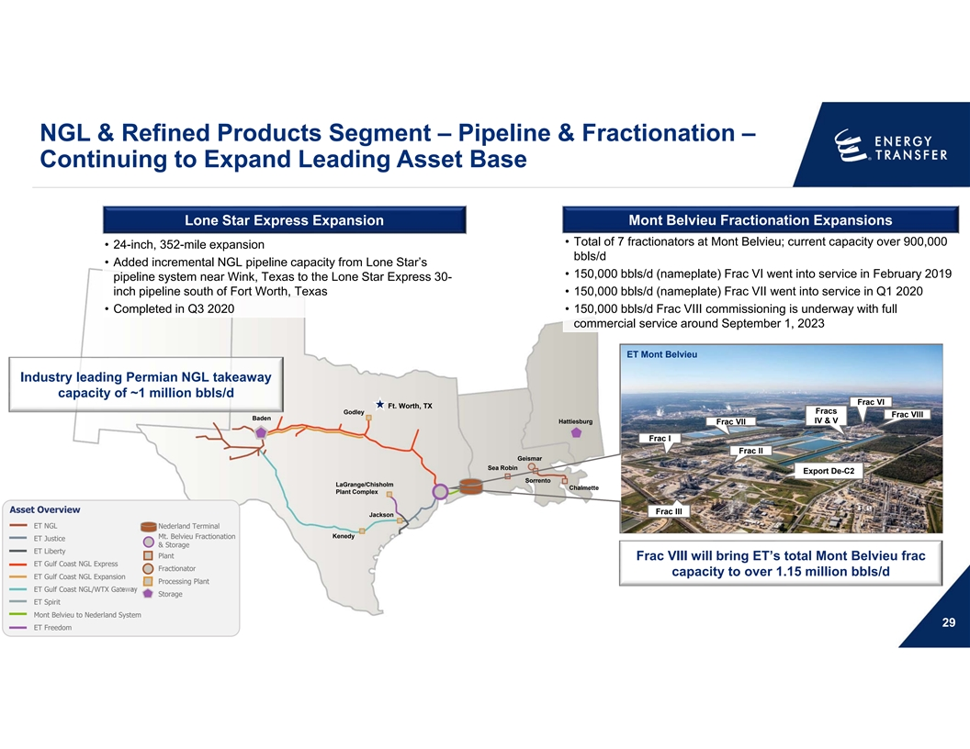
NGL & Refined Products Segment – Pipeline & Fractionation – Continuing to Expand Leading Asset Base Lone Star Express Expansion Mont Belvieu Fractionation Expansions • Total of 7 fractionators at Mont Belvieu; current capacity over 900,000 • 24-inch, 352-mile expansion bbls/d • Added incremental NGL pipeline capacity from Lone Star’s • 150,000 bbls/d (nameplate) Frac VI went into service in February 2019 pipeline system near Wink, Texas to the Lone Star Express 30- inch pipeline south of Fort Worth, Texas • 150,000 bbls/d (nameplate) Frac VII went into service in Q1 2020 • Completed in Q3 2020 • 150,000 bbls/d Frac VIII commissioning is underway with full commercial service around September 1, 2023 ET Mont Belvieu Industry leading Permian NGL takeaway capacity of ~1 million bbls/d Frac VI Ft. Worth, TX Fracs Godley Frac VIII Baden Hattiesburg IV & V Frac VII Frac I Frac II Geismar Sea Robin Export De-C2 Sorrento LaGrange/Chisholm Chalmette Plant Complex Asset Overview Frac III Jackson ET NGL Nederland Terminal Kenedy Mt. Belvieu Fractionation ET Justice & Storage ET Liberty Plant Frac VIII will bring ET’s total Mont Belvieu frac ET Gulf Coast NGL Express Fractionator capacity to over 1.15 million bbls/d ET Gulf Coast NGL Expansion Processing Plant ET Gulf Coast NGL/WTX Gateway Storage ET Spirit Mont Belvieu to Nederland System 29 ET Freedom

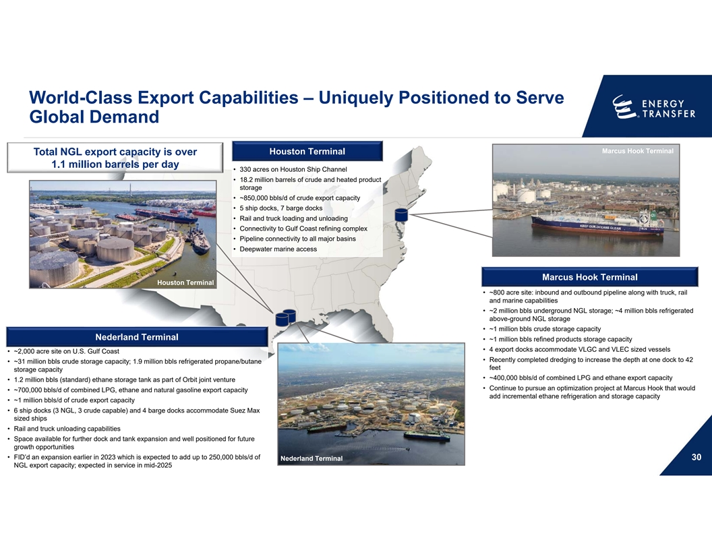
World-Class Export Capabilities – Uniquely Positioned to Serve Global Demand Marcus Hook Terminal Houston Terminal Total NGL export capacity is over 1.1 million barrels per day • 330 acres on Houston Ship Channel • 18.2 million barrels of crude and heated product storage • ~850,000 bbls/d of crude export capacity • 5 ship docks, 7 barge docks • Rail and truck loading and unloading • Connectivity to Gulf Coast refining complex • Pipeline connectivity to all major basins • Deepwater marine access Marcus Hook Terminal Houston Terminal • ~800 acre site: inbound and outbound pipeline along with truck, rail and marine capabilities • ~2 million bbls underground NGL storage; ~4 million bbls refrigerated above-ground NGL storage • ~1 million bbls crude storage capacity Nederland Terminal • ~1 million bbls refined products storage capacity • 4 export docks accommodate VLGC and VLEC sized vessels • ~2,000 acre site on U.S. Gulf Coast • Recently completed dredging to increase the depth at one dock to 42 • ~31 million bbls crude storage capacity; 1.9 million bbls refrigerated propane/butane feet storage capacity • ~400,000 bbls/d of combined LPG and ethane export capacity • 1.2 million bbls (standard) ethane storage tank as part of Orbit joint venture • Continue to pursue an optimization project at Marcus Hook that would • ~700,000 bbls/d of combined LPG, ethane and natural gasoline export capacity add incremental ethane refrigeration and storage capacity • ~1 million bbls/d of crude export capacity • 6 ship docks (3 NGL, 3 crude capable) and 4 barge docks accommodate Suez Max sized ships • Rail and truck unloading capabilities • Space available for further dock and tank expansion and well positioned for future growth opportunities • FID’d an expansion earlier in 2023 which is expected to add up to 250,000 bbls/d of 30 Nederland Terminal NGL export capacity; expected in service in mid-2025

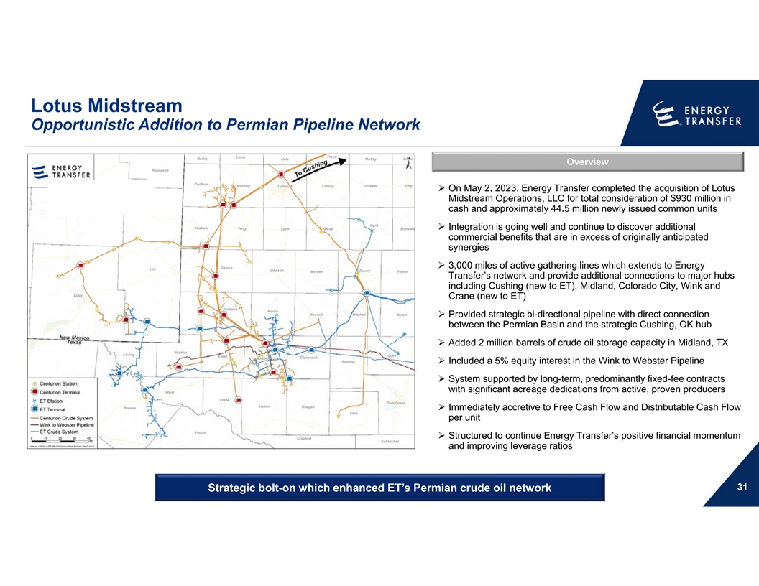
Lotus Midstream Opportunistic Addition to Permian Pipeline Network Overview Ø On May 2, 2023, Energy Transfer completed the acquisition of Lotus Midstream Operations, LLC for total consideration of $930 million in cash and approximately 44.5 million newly issued common units Ø Integration is going well and continue to discover additional commercial benefits that are in excess of originally anticipated synergies Ø 3,000 miles of active gathering lines which extends to Energy Transfer’s network and provide additional connections to major hubs including Cushing (new to ET), Midland, Colorado City, Wink and Crane (new to ET) Ø Provided strategic bi-directional pipeline with direct connection between the Permian Basin and the strategic Cushing, OK hub Ø Added 2 million barrels of crude oil storage capacity in Midland, TX Ø Included a 5% equity interest in the Wink to Webster Pipeline Ø System supported by long-term, predominantly fixed-fee contracts with significant acreage dedications from active, proven producers Ø Immediately accretive to Free Cash Flow and Distributable Cash Flow per unit Ø Structured to continue Energy Transfer’s positive financial momentum and improving leverage ratios 31 Strategic bolt-on which enhanced ET’s Permian crude oil network

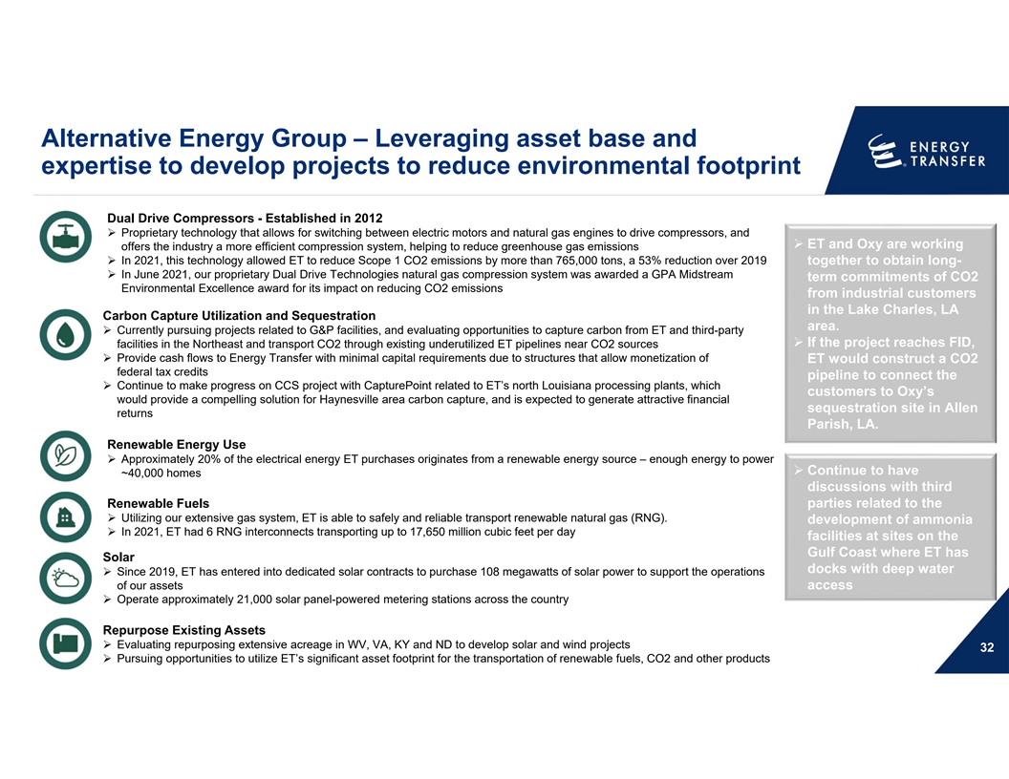
Alternative Energy Group – Leveraging asset base and expertise to develop projects to reduce environmental footprint Dual Drive Compressors - Established in 2012 Ø Proprietary technology that allows for switching between electric motors and natural gas engines to drive compressors, and Ø ET and Oxy are working offers the industry a more efficient compression system, helping to reduce greenhouse gas emissions Ø In 2021, this technology allowed ET to reduce Scope 1 CO2 emissions by more than 765,000 tons, a 53% reduction over 2019 together to obtain long- Ø In June 2021, our proprietary Dual Drive Technologies natural gas compression system was awarded a GPA Midstream term commitments of CO2 Environmental Excellence award for its impact on reducing CO2 emissions from industrial customers in the Lake Charles, LA Carbon Capture Utilization and Sequestration area. Ø Currently pursuing projects related to G&P facilities, and evaluating opportunities to capture carbon from ET and third-party Ø If the project reaches FID, facilities in the Northeast and transport CO2 through existing underutilized ET pipelines near CO2 sources Ø Provide cash flows to Energy Transfer with minimal capital requirements due to structures that allow monetization of ET would construct a CO2 federal tax credits pipeline to connect the Ø Continue to make progress on CCS project with CapturePoint related to ET’s north Louisiana processing plants, which customers to Oxy’s would provide a compelling solution for Haynesville area carbon capture, and is expected to generate attractive financial sequestration site in Allen returns Parish, LA. Renewable Energy Use Ø Approximately 20% of the electrical energy ET purchases originates from a renewable energy source – enough energy to power Ø Continue to have ~40,000 homes discussions with third Renewable Fuels parties related to the Ø Utilizing our extensive gas system, ET is able to safely and reliable transport renewable natural gas (RNG). development of ammonia Ø In 2021, ET had 6 RNG interconnects transporting up to 17,650 million cubic feet per day facilities at sites on the Gulf Coast where ET has Solar docks with deep water Ø Since 2019, ET has entered into dedicated solar contracts to purchase 108 megawatts of solar power to support the operations of our assets access Long Leaf Pines Ecosystem Restoration - TX Ø Operate approximately 21,000 solar panel-powered metering stations across the country Repurpose Existing Assets Ø Evaluating repurposing extensive acreage in WV, VA, KY and ND to develop solar and wind projects 32 Ø Pursuing opportunities to utilize ET’s significant asset footprint for the transportation of renewable fuels, CO2 and other products

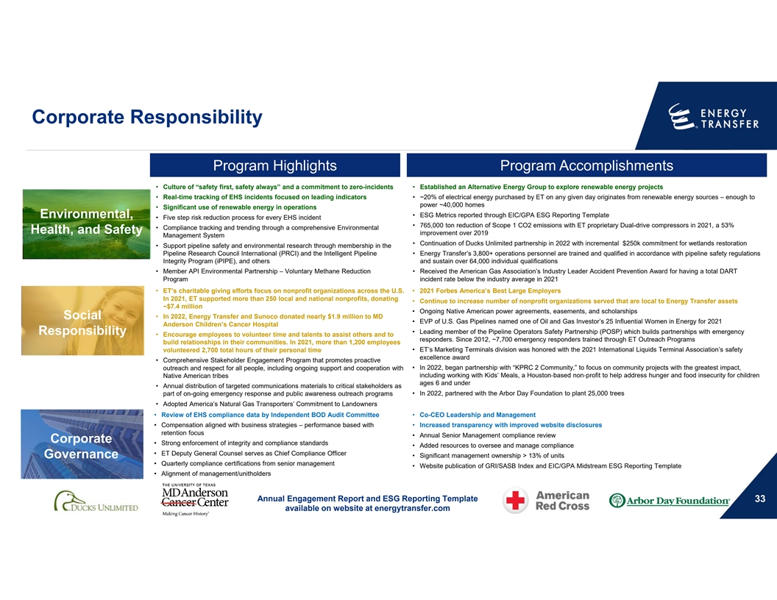
Corporate Responsibility Program Highlights Program Accomplishments • Culture of “safety first, safety always” and a commitment to zero-incidents • Established an Alternative Energy Group to explore renewable energy projects • Real-time tracking of EHS incidents focused on leading indicators • ~20% of electrical energy purchased by ET on any given day originates from renewable energy sources – enough to power ~40,000 homes • Significant use of renewable energy in operations • ESG Metrics reported through EIC/GPA ESG Reporting Template Environmental, • Five step risk reduction process for every EHS incident • 765,000 ton reduction of Scope 1 CO2 emissions with ET proprietary Dual-drive compressors in 2021, a 53% • Compliance tracking and trending through a comprehensive Environmental Health, and Safety improvement over 2019 Management System • Continuation of Ducks Unlimited partnership in 2022 with incremental $250k commitment for wetlands restoration • Support pipeline safety and environmental research through membership in the Pipeline Research Council International (PRCI) and the Intelligent Pipeline • Energy Transfer’s 3,800+ operations personnel are trained and qualified in accordance with pipeline safety regulations Integrity Program (iPIPE), and others and sustain over 64,000 individual qualifications • Member API Environmental Partnership – Voluntary Methane Reduction • Received the American Gas Association’s Industry Leader Accident Prevention Award for having a total DART Program incident rate below the industry average in 2021 • ET’s charitable giving efforts focus on nonprofit organizations across the U.S. • 2021 Forbes America’s Best Large Employers In 2021, ET supported more than 250 local and national nonprofits, donating • Continue to increase number of nonprofit organizations served that are local to Energy Transfer assets ~$7.4 million • Ongoing Native American power agreements, easements, and scholarships • In 2022, Energy Transfer and Sunoco donated nearly $1.9 million to MD Social • EVP of U.S. Gas Pipelines named one of Oil and Gas Investor’s 25 Influential Women in Energy for 2021 Anderson Children’s Cancer Hospital • Leading member of the Pipeline Operators Safety Partnership (POSP) which builds partnerships with emergency Responsibility • Encourage employees to volunteer time and talents to assist others and to responders. Since 2012, ~7,700 emergency responders trained through ET Outreach Programs build relationships in their communities. In 2021, more than 1,200 employees volunteered 2,700 total hours of their personal time • ET’s Marketing Terminals division was honored with the 2021 International Liquids Terminal Association’s safety excellence award • Comprehensive Stakeholder Engagement Program that promotes proactive • In 2022, began partnership with “KPRC 2 Community,” to focus on community projects with the greatest impact, outreach and respect for all people, including ongoing support and cooperation with including working with Kids’ Meals, a Houston‐based non‐profit to help address hunger and food insecurity for children Native American tribes ages 6 and under • Annual distribution of targeted communications materials to critical stakeholders as part of on-going emergency response and public awareness outreach programs • In 2022, partnered with the Arbor Day Foundation to plant 25,000 trees • Adopted America’s Natural Gas Transporters’ Commitment to Landowners • Review of EHS compliance data by Independent BOD Audit Committee • Co-CEO Leadership and Management • Compensation aligned with business strategies – performance based with • Increased transparency with improved website disclosures retention focus • Annual Senior Management compliance review Corporate • Strong enforcement of integrity and compliance standards • Added resources to oversee and manage compliance • ET Deputy General Counsel serves as Chief Compliance Officer • Significant management ownership > 13% of units Governance • Quarterly compliance certifications from senior management • Website publication of GRI/SASB Index and EIC/GPA Midstream ESG Reporting Template • Alignment of management/unitholders Annual Engagement Report and ESG Reporting Template 33 available on website at energytransfer.com

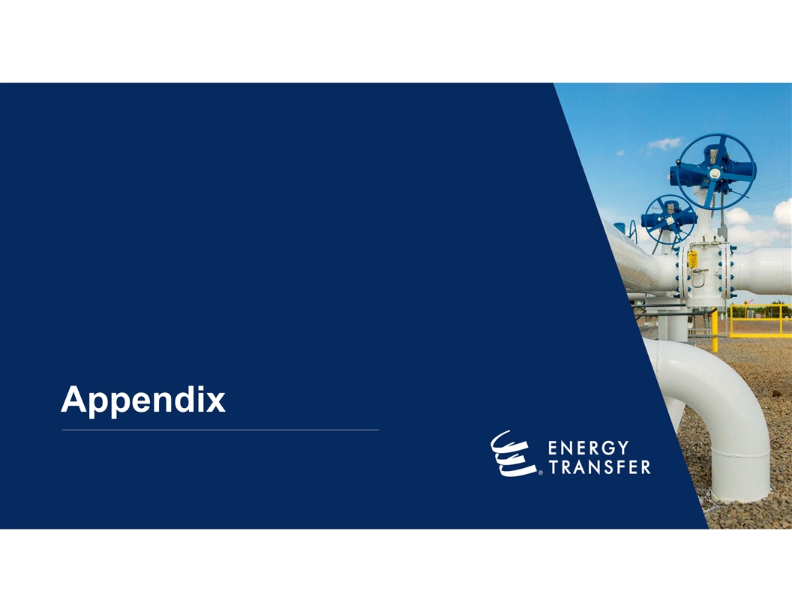
Appendix

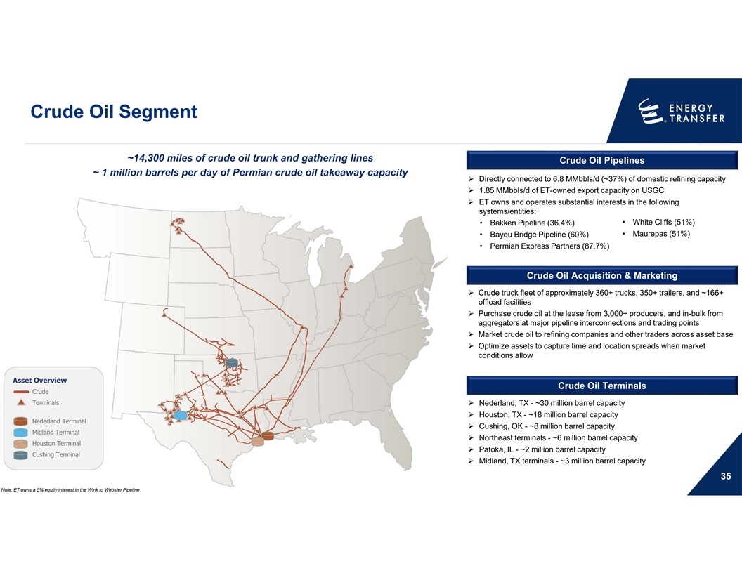
Crude Oil Segment ~14,300 miles of crude oil trunk and gathering lines Crude Oil Pipelines ~ 1 million barrels per day of Permian crude oil takeaway capacity Ø Directly connected to 6.8 MMbbls/d (~37%) of domestic refining capacity Ø 1.85 MMbbls/d of ET-owned export capacity on USGC Ø ET owns and operates substantial interests in the following systems/entities: • White Cliffs (51%) • Bakken Pipeline (36.4%) • Bayou Bridge Pipeline (60%) • Maurepas (51%) • Permian Express Partners (87.7%) Crude Oil Acquisition & Marketing Ø Crude truck fleet of approximately 360+ trucks, 350+ trailers, and ~166+ offload facilities Ø Purchase crude oil at the lease from 3,000+ producers, and in-bulk from aggregators at major pipeline interconnections and trading points Ø Market crude oil to refining companies and other traders across asset base Ø Optimize assets to capture time and location spreads when market conditions allow Asset Overview Crude Oil Terminals Crude Terminals Ø Nederland, TX - ~30 million barrel capacity Ø Houston, TX - ~18 million barrel capacity Nederland Terminal Ø Cushing, OK - ~8 million barrel capacity Midland Terminal Ø Northeast terminals - ~6 million barrel capacity Houston Terminal Ø Patoka, IL - ~2 million barrel capacity Cushing Terminal Ø Midland, TX terminals - ~3 million barrel capacity 35 Note: ET owns a 5% equity interest in the Wink to Webster Pipeline

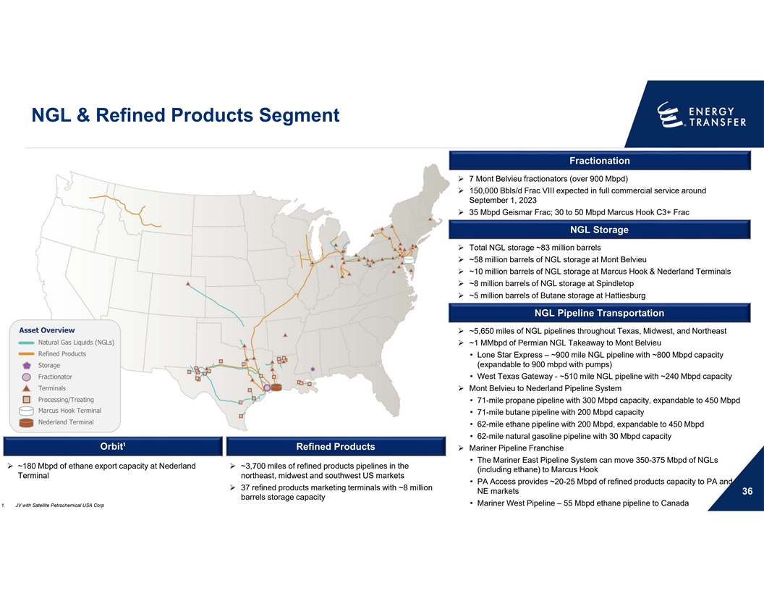
NGL & Refined Products Segment Fractionation Ø 7 Mont Belvieu fractionators (over 900 Mbpd) Ø 150,000 Bbls/d Frac VIII expected in full commercial service around September 1, 2023 Ø 35 Mbpd Geismar Frac; 30 to 50 Mbpd Marcus Hook C3+ Frac NGL Storage Ø Total NGL storage ~83 million barrels Ø ~58 million barrels of NGL storage at Mont Belvieu Ø ~10 million barrels of NGL storage at Marcus Hook & Nederland Terminals Ø ~8 million barrels of NGL storage at Spindletop Ø ~5 million barrels of Butane storage at Hattiesburg NGL Pipeline Transportation Asset Overview Ø ~5,650 miles of NGL pipelines throughout Texas, Midwest, and Northeast Natural Gas Liquids (NGLs) Ø ~1 MMbpd of Permian NGL Takeaway to Mont Belvieu Refined Products • Lone Star Express – ~900 mile NGL pipeline with ~800 Mbpd capacity (expandable to 900 mbpd with pumps) Storage Fractionator • West Texas Gateway - ~510 mile NGL pipeline with ~240 Mbpd capacity TerminalsØ Mont Belvieu to Nederland Pipeline System Processing/Treating • 71-mile propane pipeline with 300 Mbpd capacity, expandable to 450 Mbpd Marcus Hook Terminal • 71-mile butane pipeline with 200 Mbpd capacity Nederland Terminal • 62-mile ethane pipeline with 200 Mbpd, expandable to 450 Mbpd • 62-mile natural gasoline pipeline with 30 Mbpd capacity Orbit¹ Refined Products Ø Mariner Pipeline Franchise • The Mariner East Pipeline System can move 350-375 Mbpd of NGLs Ø ~180 Mbpd of ethane export capacity at Nederland Ø ~3,700 miles of refined products pipelines in the (including ethane) to Marcus Hook Terminal northeast, midwest and southwest US markets • PA Access provides ~20-25 Mbpd of refined products capacity to PA and Ø 37 refined products marketing terminals with ~8 million NE markets 36 barrels storage capacity • Mariner West Pipeline – 55 Mbpd ethane pipeline to Canada 1. JV with Satellite Petrochemical USA Corp

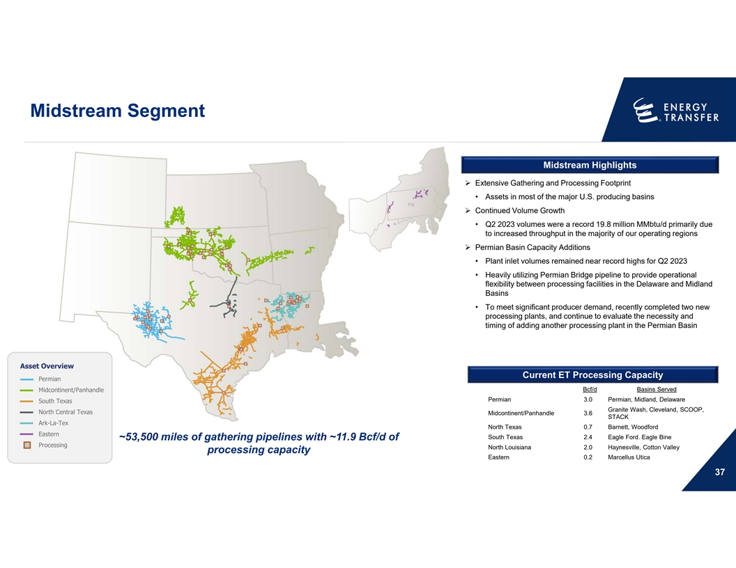
Midstream Segment Midstream Highlights Ø Extensive Gathering and Processing Footprint • Assets in most of the major U.S. producing basins PA Ø Continued Volume Growth • Q2 2023 volumes were a record 19.8 million MMbtu/d primarily due to increased throughput in the majority of our operating regions Ø Permian Basin Capacity Additions • Plant inlet volumes remained near record highs for Q2 2023 • Heavily utilizing Permian Bridge pipeline to provide operational flexibility between processing facilities in the Delaware and Midland Basins • To meet significant producer demand, recently completed two new processing plants, and continue to evaluate the necessity and timing of adding another processing plant in the Permian Basin Asset Overview Current Processing Capacity Current ET Processing Capacity Permian Bcf/d Basins Served Midcontinent/Panhandle Permian 3.0 Permian, Midland, Delaware South Texas Granite Wash, Cleveland, SCOOP, North Central Texas Midcontinent/Panhandle 3.6 STACK Ark-La-Tex North Texas 0.7 Barnett, Woodford Eastern South Texas 2.4 Eagle Ford. Eagle Bine ~53,500 miles of gathering pipelines with ~11.9 Bcf/d of Processing North Louisiana 2.0 Haynesville, Cotton Valley processing capacity Eastern 0.2 Marcellus Utica 37

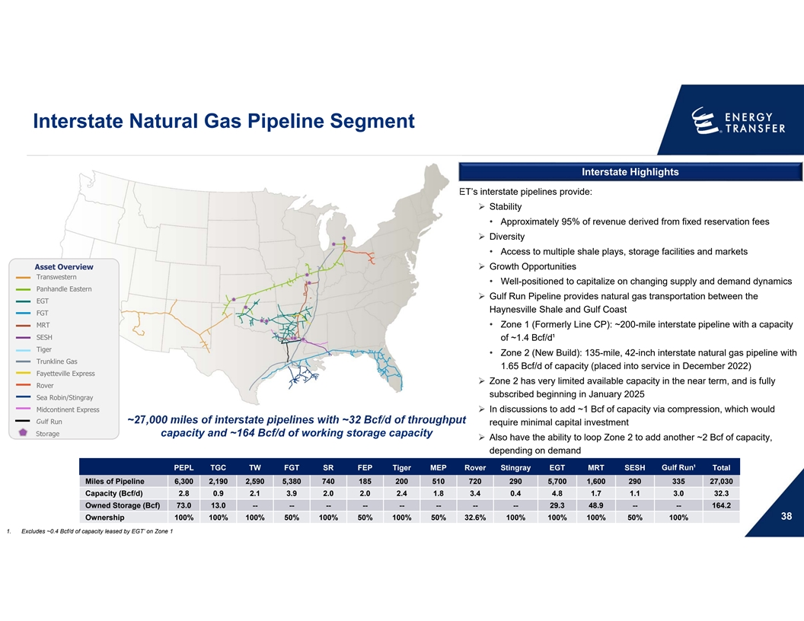
Interstate Natural Gas Pipeline Segment Interstate Highlights ET’s interstate pipelines provide: Ø Stability • Approximately 95% of revenue derived from fixed reservation fees Ø Diversity • Access to multiple shale plays, storage facilities and markets Asset OverviewØ Growth Opportunities Transwestern • Well-positioned to capitalize on changing supply and demand dynamics Panhandle Eastern Ø Gulf Run Pipeline provides natural gas transportation between the EGT Haynesville Shale and Gulf Coast FGT MRT • Zone 1 (Formerly Line CP): ~200-mile interstate pipeline with a capacity SESH of ~1.4 Bcf/d¹ Tiger • Zone 2 (New Build): 135-mile, 42-inch interstate natural gas pipeline with Trunkline Gas 1.65 Bcf/d of capacity (placed into service in December 2022) Fayetteville Express Ø Zone 2 has very limited available capacity in the near term, and is fully Rover subscribed beginning in January 2025 Sea Robin/Stingray Midcontinent ExpressØ In discussions to add ~1 Bcf of capacity via compression, which would Gulf Run ~27,000 miles of interstate pipelines with ~32 Bcf/d of throughput require minimal capital investment Storage capacity and ~164 Bcf/d of working storage capacity Ø Also have the ability to loop Zone 2 to add another ~2 Bcf of capacity, depending on demand PEPL TGC TW FGT SR FEP Tiger MEP Rover Stingray EGT MRT SESH Gulf Run¹ Total Miles of Pipeline 6,300 2,190 2,590 5,380 740 185 200 510 720 290 5,700 1,600 290 335 27,030 Capacity (Bcf/d) 2.8 0.9 2.1 3.9 2.0 2.0 2.4 1.8 3.4 0.4 4.8 1.7 1.1 3.0 32.3 Owned Storage (Bcf) 73.0 13.0 -- -- -- -- -- -- -- -- 29.3 48.9 -- -- 164.2 38 Ownership 100% 100% 100% 50% 100% 50% 100% 50% 32.6% 100% 100% 100% 50% 100% 1. Excludes ~0.4 Bcf/d of capacity leased by EGT’ on Zone 1

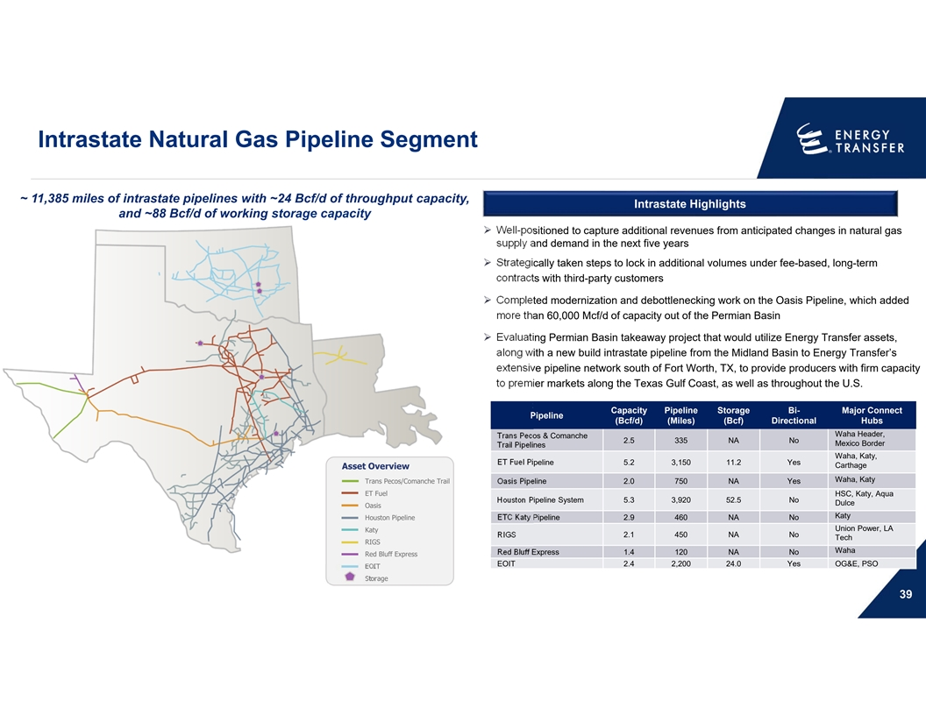
Intrastate Natural Gas Pipeline Segment ~ 11,385 miles of intrastate pipelines with ~24 Bcf/d of throughput capacity, Intrastate Highlights and ~88 Bcf/d of working storage capacity Ø Well-positioned to capture additional revenues from anticipated changes in natural gas supply and demand in the next five years Ø Strategically taken steps to lock in additional volumes under fee-based, long-term contracts with third-party customers Ø Completed modernization and debottlenecking work on the Oasis Pipeline, which added more than 60,000 Mcf/d of capacity out of the Permian Basin Ø Evaluating Permian Basin takeaway project that would utilize Energy Transfer assets, along with a new build intrastate pipeline from the Midland Basin to Energy Transfer’s extensive pipeline network south of Fort Worth, TX, to provide producers with firm capacity to premier markets along the Texas Gulf Coast, as well as throughout the U.S. Capacity Pipeline Storage Bi- Major Connect Pipeline (Bcf/d) (Miles) (Bcf) Directional Hubs Waha Header, Trans Pecos & Comanche 2.5 335 NA No Mexico Border Trail Pipelines Waha, Katy, ET Fuel Pipeline 5.2 3,150 11.2 Yes Carthage Asset Overview Waha, Katy Trans Pecos/Comanche Trail Oasis Pipeline 2.0 750 NA Yes ET Fuel HSC, Katy, Aqua Houston Pipeline System 5.3 3,920 52.5 No Dulce Oasis Katy Houston Pipeline ETC Katy Pipeline 2.9 460 NA No Union Power, LA Katy RIGS 2.1 450 NA No Tech RIGS Waha Red Bluff Express 1.4 120 NA No Red Bluff Express EOIT 2.4 2,200 24.0 Yes OG&E, PSO EOIT Storage 39

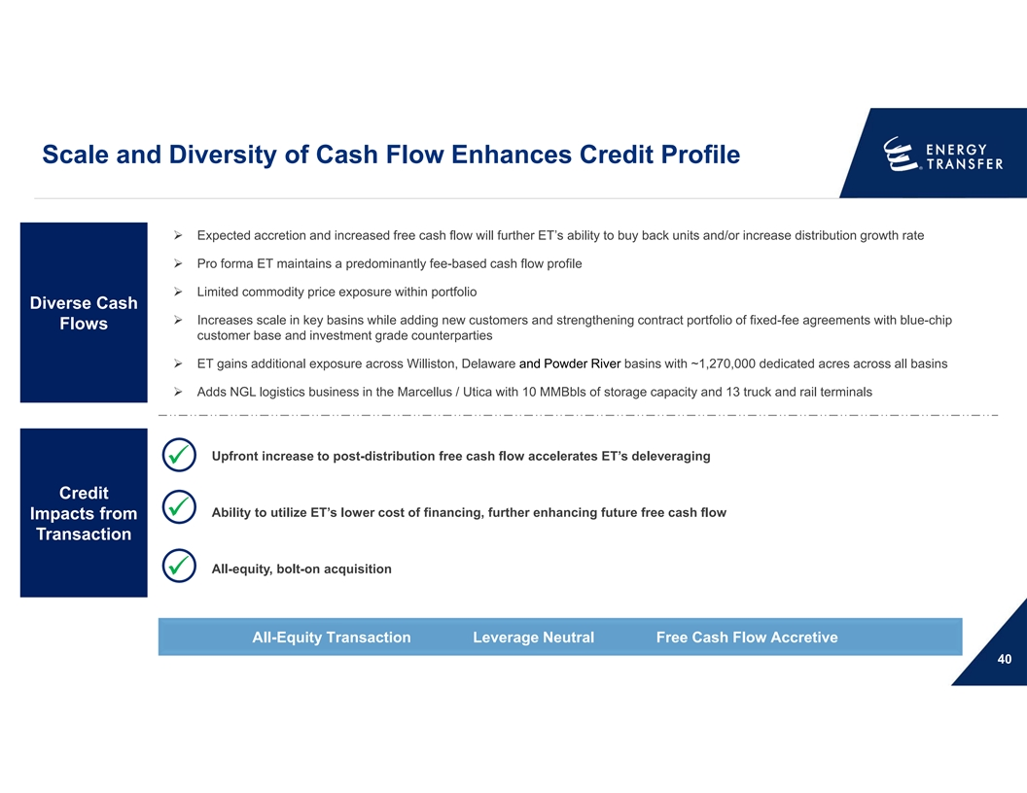
Scale and Diversity of Cash Flow Enhances Credit Profile Ø Expected accretion and increased free cash flow will further ET’s ability to buy back units and/or increase distribution growth rate Ø Pro forma ET maintains a predominantly fee-based cash flow profile Ø Limited commodity price exposure within portfolio Diverse Cash Ø Increases scale in key basins while adding new customers and strengthening contract portfolio of fixed-fee agreements with blue-chip Flows customer base and investment grade counterparties Ø ET gains additional exposure across Williston, Delaware and Powder River basins with ~1,270,000 dedicated acres across all basins Ø Adds NGL logistics business in the Marcellus / Utica with 10 MMBbls of storage capacity and 13 truck and rail terminals Upfront increase to post-distribution free cash flow accelerates ET’s deleveraging üv Credit Ability to utilize ET’s lower cost of financing, further enhancing future free cash flow Impacts from üv Transaction All-equity, bolt-on acquisition üv All-Equity Transaction Leverage Neutral Free Cash Flow Accretive 40

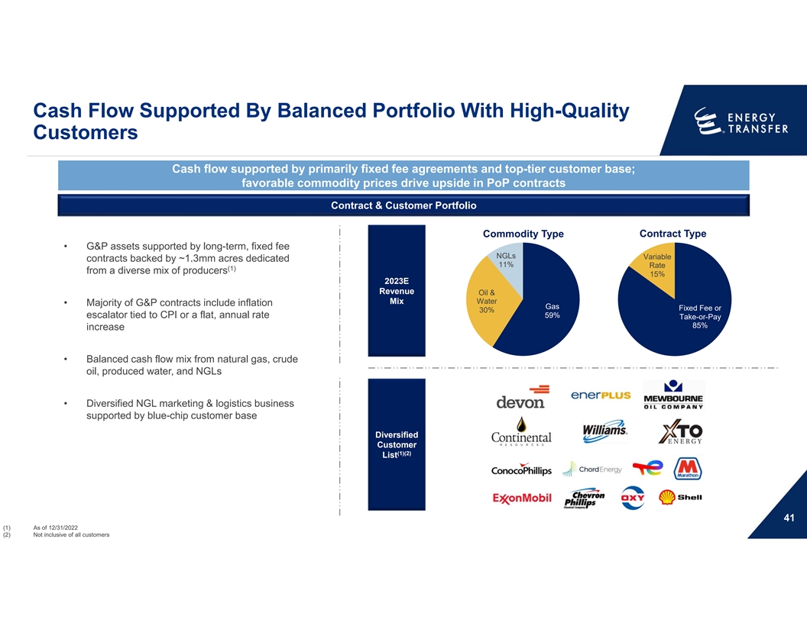
Cash Flow Supported By Balanced Portfolio With High-Quality Customers Cash flow supported by primarily fixed fee agreements and top-tier customer base; favorable commodity prices drive upside in PoP contracts Contract & Customer Portfolio Commodity Type Contract Type • G&P assets supported by long-term, fixed fee NGLs Variable contracts backed by ~1.3mm acres dedicated 11% Rate (1) from a diverse mix of producers 15% 2023E Revenue Oil & Mix Water • Majority of G&P contracts include inflation Gas Fixed Fee or 30% 59% escalator tied to CPI or a flat, annual rate Take-or-Pay 85% increase • Balanced cash flow mix from natural gas, crude oil, produced water, and NGLs • Diversified NGL marketing & logistics business supported by blue-chip customer base Diversified Customer (1)(2) List 41 (1) As of 12/31/2022 (2) Not inclusive of all customers

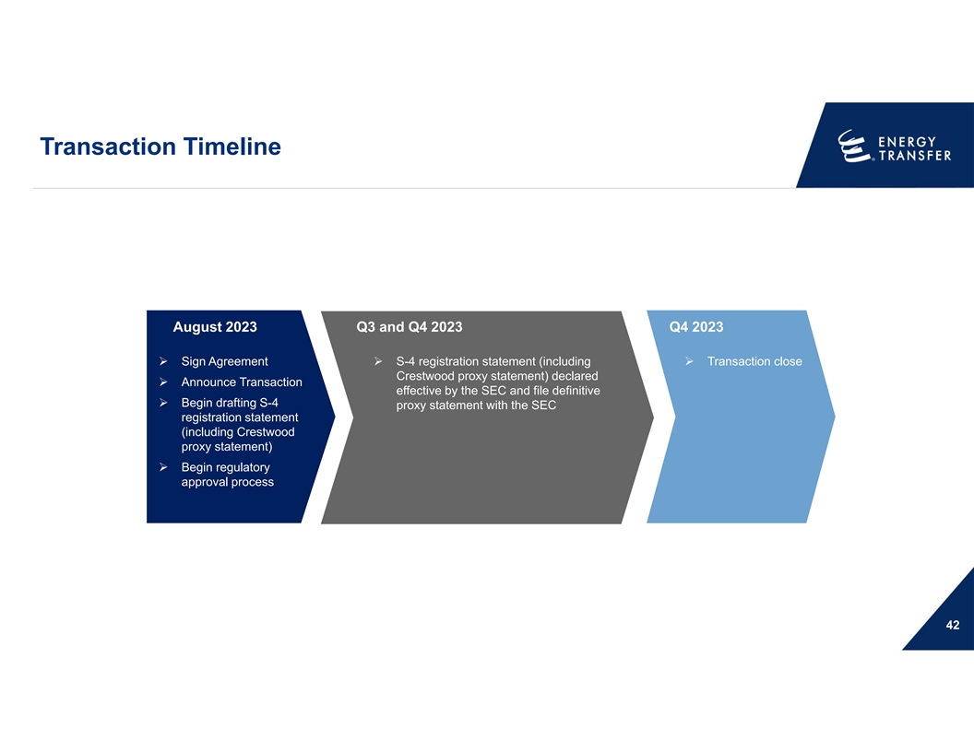
Transaction Timeline August 2023 Q3 and Q4 2023 Q4 2023 Ø Sign AgreementØ S-4 registration statement (including Ø Transaction close Crestwood proxy statement) declared Ø Announce Transaction effective by the SEC and file definitive Ø Begin drafting S-4 proxy statement with the SEC registration statement (including Crestwood proxy statement) Ø Begin regulatory approval process 42

Non-GAAP Reconciliations 43

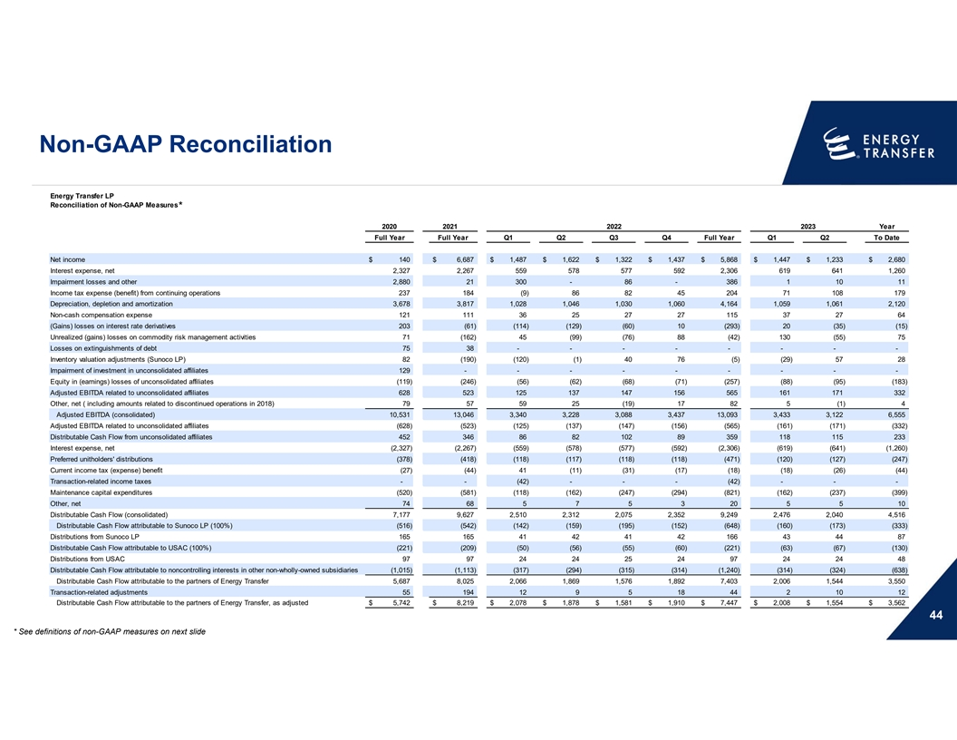
Non-GAAP Reconciliation Energy Transfer LP Reconciliation of Non-GAAP Measures * Year 2020 2021 2022 2023 Full Year Full Year Q1 Q2 Q3 Q4 Full Year Q1 Q2 To Date Net income $ 140 $ 6,687 $ 1,487 $ 1,622 $ 1,322 $ 1,437 $ 5,868 $ 1,447 $ 1,233 $ 2,680 Interest expense, net 2,327 2,267 5 59 578 577 592 2,306 619 641 1,260 Impairment losses and other 2,880 21 300 - 86 - 386 1 10 11 Income tax expense (benefit) from continuing operations 237 184 (9) 86 82 45 204 71 108 179 Depreciation, depletion and amortization 3,678 3,817 1,028 1,046 1,030 1,060 4,164 1,059 1,061 2,120 Non-cash compensation expense 121 111 36 25 27 27 115 37 27 64 (Gains) losses on interest rate derivatives 203 (61) (114) (129) (60) 10 (293) 20 (35) (15) Unrealized (gains) losses on commodity risk management activities 71 (162) 45 (99) (76) 88 (42) 130 (55) 75 Losses on extinguishments of debt 75 38 - - - - - - - - Inventory valuation adjustments (Sunoco LP) 82 (190) (120) (1) 40 76 (5) (29) 57 28 Impairment of investment in unconsolidated affiliates 129 - - - - - - - - - Equity in (earnings) losses of unconsolidated affiliates (119) (246) (56) (62) (68) (71) (257) (88) (95) (183) Adjusted EBITDA related to unconsolidated affiliates 628 523 125 137 147 156 565 161 171 332 Other, net ( including amounts related to discontinued operations in 2018) 79 57 59 25 (19) 17 82 5 (1) 4 Adjusted EBITDA (consolidated) 10,531 13,046 3,340 3,228 3,088 3,437 13,093 3,433 3,122 6,555 Adjusted EBITDA related to unconsolidated affiliates (628) (523) (125) (137) (147) (156) (565) (161) (171) (332) Distributable Cash Flow from unconsolidated affiliates 452 346 86 82 102 89 359 118 115 233 Interest expense, net (2,327) (2,267) (559) (578) (577) (592) (2,306) ( 619) (641) (1,260) Preferred unitholders' distributions (378) (418) (118) (117) (118) (118) (471) (120) (127) (247) Current income tax (expense) benefit (27) (44) 41 (11) (31) (17) (18) (18) (26) (44) Transaction-related income taxes - - (42) - - - (42) - - - Maintenance capital expenditures (520) (581) (118) (162) (247) (294) (821) (162) (237) (399) Other, net 74 68 5 7 5 3 20 5 5 10 Distributable Cash Flow (consolidated) 7,177 9,627 2,510 2,312 2,075 2,352 9,249 2,476 2,040 4,516 Distributable Cash Flow attributable to Sunoco LP (100%) (516) (542) (142) (159) (195) (152) (648) (160) (173) (333) Distributions from Sunoco LP 165 165 41 42 41 42 166 43 44 87 Distributable Cash Flow attributable to USAC (100%) (221) (209) (50) (56) (55) (60) (221) (63) (67) (130) Distributions from USAC 97 97 24 24 25 24 97 24 24 48 Distributable Cash Flow attributable to noncontrolling interests in other non-wholly-owned subsidiaries (1,015) (1,113) (317) (294) (315) (314) (1,240) ( 314) (324) (638) Distributable Cash Flow attributable to the partners of Energy Transfer 5,687 8,025 2,066 1,869 1,576 1,892 7,403 2,006 1,544 3,550 Transaction-related adjustments 55 194 12 9 5 18 44 2 10 12 Distributable Cash Flow attributable to the partners of Energy Transfer, as adjusted $ 5,742 $ 8,219 $ 2,078 $ 1,878 $ 1,581 $ 1,910 $ 7,447 $ 2,008 $ 1,554 $ 3,562 44 * See definitions of non-GAAP measures on next slide

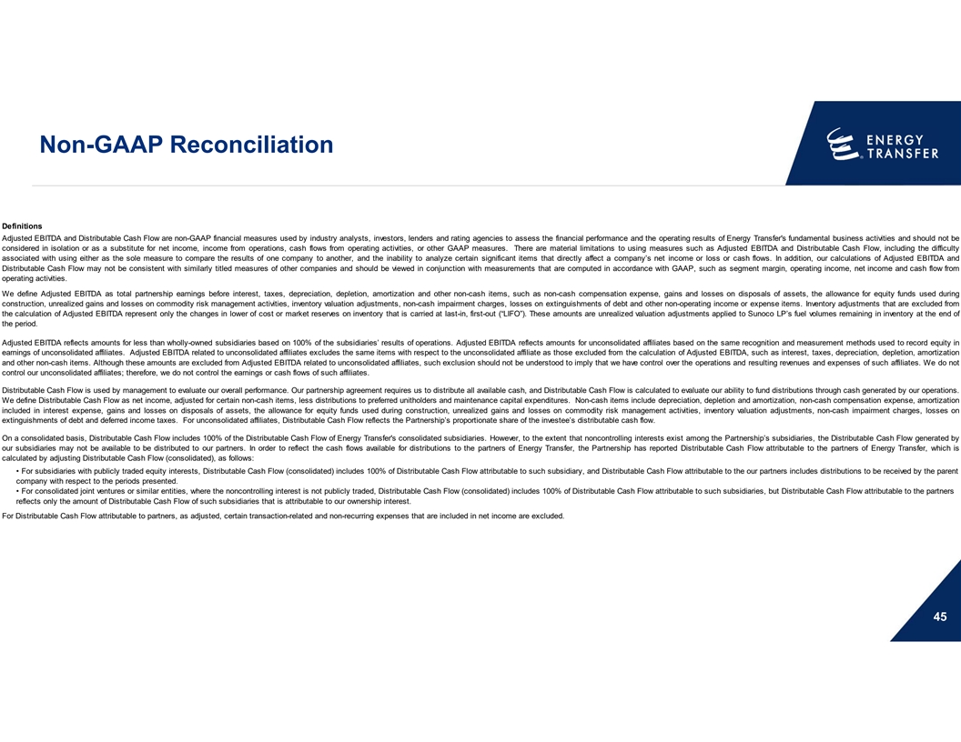
Non-GAAP Reconciliation Definitions Adjusted EBITDA and Distributable Cash Flow are non-GAAP financial measures used by industry analysts, investors, lenders and rating agencies to assess the financial performance and the operating results of Energy Transfer's fundamental business activities and should not be considered in isolation or as a substitute for net income, income from operations, cash flows from operating activities, or other GAAP measures. There are material limitations to using measures such as Adjusted EBITDA and Distributable Cash Flow, including the difficulty associated with using either as the sole measure to compare the results of one company to another, and the inability to analyze certain significant items that directly affect a company’s net income or loss or cash flows. In addition, our calculations of Adjusted EBITDA and Distributable Cash Flow may not be consistent with similarly titled measures of other companies and should be viewed in conjunction with measurements that are computed in accordance with GAAP, such as segment margin, operating income, net income and cash flow from operating activities. We define Adjusted EBITDA as total partnership earnings before interest, taxes, depreciation, depletion, amortization and other non-cash items, such as non-cash compensation expense, gains and losses on disposals of assets, the allowance for equity funds used during construction, unrealized gains and losses on commodity risk management activities, inventory valuation adjustments, non-cash impairment charges, losses on extinguishments of debt and other non-operating income or expense items. Inventory adjustments that are excluded from the calculation of Adjusted EBITDA represent only the changes in lower of cost or market reserves on inventory that is carried at last-in, first-out (“LIFO”). These amounts are unrealized valuation adjustments applied to Sunoco LP’s fuel volumes remaining in inventory at the end of the period. Adjusted EBITDA reflects amounts for less than wholly-owned subsidiaries based on 100% of the subsidiaries’ results of operations. Adjusted EBITDA reflects amounts for unconsolidated affiliates based on the same recognition and measurement methods used to record equity in earnings of unconsolidated affiliates. Adjusted EBITDA related to unconsolidated affiliates excludes the same items with respect to the unconsolidated affiliate as those excluded from the calculation of Adjusted EBITDA, such as interest, taxes, depreciation, depletion, amortization and other non-cash items. Although these amounts are excluded from Adjusted EBITDA related to unconsolidated affiliates, such exclusion should not be understood to imply that we have control over the operations and resulting revenues and expenses of such affiliates. We do not control our unconsolidated affiliates; therefore, we do not control the earnings or cash flows of such affiliates. Distributable Cash Flow is used by management to evaluate our overall performance. Our partnership agreement requires us to distribute all available cash, and Distributable Cash Flow is calculated to evaluate our ability to fund distributions through cash generated by our operations. We define Distributable Cash Flow as net income, adjusted for certain non-cash items, less distributions to preferred unitholders and maintenance capital expenditures. Non-cash items include depreciation, depletion and amortization, non-cash compensation expense, amortization included in interest expense, gains and losses on disposals of assets, the allowance for equity funds used during construction, unrealized gains and losses on commodity risk management activities, inventory valuation adjustments, non-cash impairment charges, losses on extinguishments of debt and deferred income taxes. For unconsolidated affiliates, Distributable Cash Flow reflects the Partnership’s proportionate share of the investee’s distributable cash flow. On a consolidated basis, Distributable Cash Flow includes 100% of the Distributable Cash Flow of Energy Transfer's consolidated subsidiaries. However, to the extent that noncontrolling interests exist among the Partnership’s subsidiaries, the Distributable Cash Flow generated by our subsidiaries may not be available to be distributed to our partners. In order to reflect the cash flows available for distributions to the partners of Energy Transfer, the Partnership has reported Distributable Cash Flow attributable to the partners of Energy Transfer, which is calculated by adjusting Distributable Cash Flow (consolidated), as follows: • For subsidiaries with publicly traded equity interests, Distributable Cash Flow (consolidated) includes 100% of Distributable Cash Flow attributable to such subsidiary, and Distributable Cash Flow attributable to the our partners includes distributions to be received by the parent company with respect to the periods presented. • For consolidated joint ventures or similar entities, where the noncontrolling interest is not publicly traded, Distributable Cash Flow (consolidated) includes 100% of Distributable Cash Flow attributable to such subsidiaries, but Distributable Cash Flow attributable to the partners reflects only the amount of Distributable Cash Flow of such subsidiaries that is attributable to our ownership interest. For Distributable Cash Flow attributable to partners, as adjusted, certain transaction-related and non-recurring expenses that are included in net income are excluded. 45

